
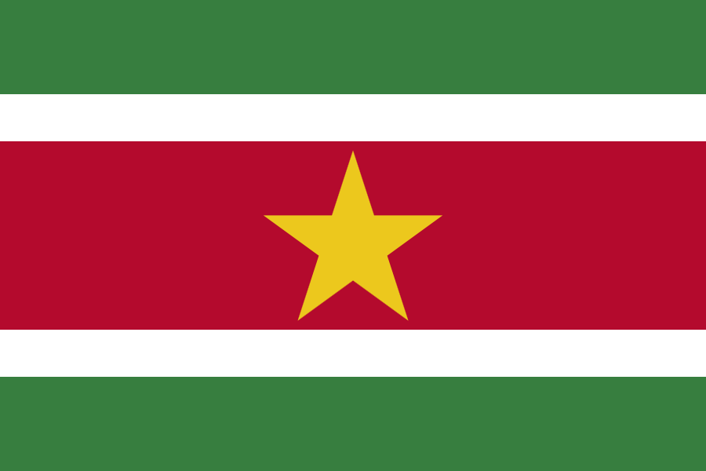

United Nations Development Programme
Country: Republic of Suriname
PROJECT DOCUMENT
Project Title: Mainstreaming global environment commitments for effective national environmental management
UNDAF Outcome(s):
By 2016, government formulates and implements harmonized, equity focused and gender sensitive MDG-oriented key legislation, policies and budgets in accordance with the Government’s commitments to international human rights conventions; 3. By 2016, quality equity focused, rights-based, and gender-sensitive data collection and analysis and harmonized information systems serve the development of informed social, economic, and environmental policies, budgets, legislation, and programmes.
UNDP Strategic Plan 2014 – 2017 Primary Outcome:
Outcome 1; Growth and development are inclusive and sustainable, incorporating productive capacities that create employment and livelihoods for the poor and excluded;;
UNDP Strategic Plan Secondary Outcome
Outcome 2: Citizen expectations for voice, development, the rule of law and accountability are met by stronger systems of democratic governance
Expected CP Outcome(s):
Expected CP Outcomes: 2. By 2016 public institutions are strengthened and possess the capacities, policy frameworks and tools to: target and deliver improved services to identified vulnerable groups, and develop and deliver to identified vulnerable and underserved groups and individuals programmes for income generation and sustainable livelihoods, life and employment skills, social protection, social housing, affordable energy and food security; 3. By 2016 public and relevant national-level institutions are strengthened and possess the institutional capacities, management instruments, policy frameworks and competencies to: promote environmentally sustainable development; adapt to and mitigate the impacts of climate change on the most vulnerable; and prepare for and empower vulnerable communities to respond to natural disasters and other anthropogenic-induced hazards.

Expected UNDAP Output(s):
Output 5 under outcome 2: Improved national institutional capacities, policy frameworks, strategies and competencies for environmental management, climate changes adaptation and mitigation in place and implementation monitored.
Output 1 under outcome 3: Improved access to timely and quality disaggregated data and analysis
Executing Entity/Implementing Partner: Ministry of Labor, Technological Development and Environment (ATM)
Responsible Partners: UNDP
Brief Summary:
As the National Capacity Self-Assessment (NCSA) of the Republic of the Suriname revealed, there are numerous capacity constraints and gaps which pose challenges for Suriname in fulfilling its commitments under the Rio Conventions and meeting its national sustainable development objectives. This project is targeted towards addressing cross-cutting capacity gaps and needs, by supporting interventions that will strengthen key government structures, as well as mechanisms for the civil society sector, to improve the institutional framework set up to implement the Rio Conventions and to deliver global environmental benefits. Under this project, capacity development support will lead to two outcomes: (1) Increased capacity of decision makers and stakeholders to manage environmental planning and processes that lead to decisions aimed at increasing global environmental benefits through better use of information and knowledge; and (2) Improved national capacities for the effective coordinated management and implementation of the Rio Conventions, and to continued leverage of financial resources to support the Conventions' objectives.
Total resources required US$ 2,380,000
Total allocated resources: US$ 2,380,000
- GEF US$ 980,000
- Government of Suriname (grant) US$ 440,000
- Government of Suriname (in-kind) US$ 625,000
- UNDP (grant) US$ 185,000
- UNDP (in-kind) US$ 50,000
- Other (in-kind) US$ 100,000

Programme Period: 2014-2017
Atlas Award ID:
Atlas Project ID:
PIMS # 4937

Start date: September 2014
End Date: September 2017
Management Arrangements: NIM
PAC Meeting Date: TBC

Agreed by (Government):
Date/Month/Year

Agreed by (Executing Entity/Implementing Partner):
Date/Month/Year

Agreed by (UNDP):
Date/Month/Year

Contents
Acronyms & Abbreviations 6
A. Project Summary 9
A.1 Project Rationale, Objectives, Outcomes/Outputs, and Activities 11
A.1.a. Cross-cutting development actions: project objective and outcomes 13
A.2 Key Indicators, Assumptions, and Risks 14
B. Country Ownership 15
B.1. Country Eligibility 15
B. 2 Country Drivenness 15
B.2.a. National Capacity Self-Assessment 16
B.2.b Sustainable Development Context 17
B.3 Institutional and Policy Context 22
B.4. Gender Context 27
B.5. Barriers to Achieving Global Environmental Objectives 29
C. Programme and Policy Conformity 32
C.1 GEF Programme Designation and Conformity 32
C.1 Project Design: GEF Alternative 35
C.1.a. Project Goal and Objective 36
C.1.b. Project Rationale 36
C.2. Expected Outcomes and Outputs 37
C.3 Sustainability and Replicability 45
C.3.a Risks and Assumptions 45
C.4. Stakeholder Involvement 47
C.5. Monitoring and Evaluation 49
D. Financing 55
D.1. Financing Plan 55
D.2. Cost-Effectiveness 60
D.3. Co-financing 61
E. Institutional Coordination and Support 62
E.1. Core Commitments and Linkages - Linkages to Other Activities and Programmes 62
E.2. Implementation and Execution Arrangements 63
Annex 1. Capacity Development Scorecard 67
Annex 2. Logical Framework 73
Annex 3. Provisional Workplan 76
Annex 4. Terms of References 77
4. a Terms of Reference- Project Board 77
4.b Terms of Reference- National Project Director 79
4.c Terms of Reference- National Project Manager 80
Annex 5. Environmental and Social Criteria (see attached) 81
Annex 6. PPG Status Report 83
Annex 7. Standard letter of agreement between UNDP & Government of Suriname 88
Annex 8. GEF endorsement letter 93
Annex 9. Letters of co-financing 93

Acronyms & Abbreviations

ABS- Algemeen Bureau Voor de Statistiek (Statistics Bureau Suriname)
ACT- Amazon Conservation Team
ACTO- Amazon Cooperation Treaty Organization
ADeK- Anton de Kom University of Suriname
ATM- Ministry of Labor, Technological Development and Environment
BAU- Business as usual
CELOS- Centre for Agricultural Research in Suriname
CI- Conservation International
CITES- Convention on International Trade in Endangered Species of Wild Fauna and Flora
CoP- Conference of the Parties
CSNR- Central Suriname Nature Reserve
DC- District Commissioner
ELS- Environmental Legal Services department of NIMOS
EME- Environmental Monitoring and Enforcement department of NIMOS
ESA- Environmental & Social Assessment
ESIA- Environmental and social impact assessments
EU- European Union
FAO- Food and Agricultural Organization of the United Nations
FCPF- Forest Carbon Partnership Facility
FDI- Foreign direct investment
FPIC- Free Prior and Informed Consent
GoS- Government of Suriname
IDB- Inter-American Development Bank
IDCS- Investment & Development Corporation Suriname
IWRM- Integrated Water Resources Management
LVV- Ministry of Agriculture and Livestock
MDGs- Millennium Development Goals
NBINS- National Biodiversity Information Network
NBAP- National Biodiversity Action Plan
NBSAP- National Biodiversity Strategy and Action Plan
NCSA- National Capacity Self-Assessment
NFI- National Forest Inventory
NGO- Non- governmental organization
NH- Ministry of Natural Resources
NIMOS- National Institute for Environment and Development in Suriname
OP- Development Plan Suriname 2012-2016
REDD+- Reduced Emissions from Deforestation and Degradation
ROGB- Ministry of Physical Planning, Land and Forest Management
RO- Ministry of Regional Development
ROM- Coordination Office for Spatial Planning and Environment
R-PP- Readiness Preparation Proposal
SBB- Foundation for Forest Management and Production Control
SIDS- Small Island Developing States
SNC- Second National Communication
SWRIS- Suriname Water Resources Information System
TBI- Tropenbos Suriname International
TOR- Terms of reference
UNCBD- United Nations Convention on Biological Diversity
UNFCCC- United Nations Framework Conventions on Climate Change
UNCCD- United National Convention to Combat Desertification
WWF- World Wildlife Fund

Part 1 - Project

A. Project Summary
The Republic of Suriname, with a land mass of 164,000km2, is located on the Northeastern coast of South America. Its flat coast is a succession of mud banks, mangroves, and narrow beaches that stretch from the Corantijn River in the West to the Marowijne River in the East. Suriname has the biggest protected tropical forest area in the world, and is one of the countries with the highest rainforest cover. Suriname has a semi-humid climate with average air temperatures ranging from 26⁰C in January up to 31⁰C in October, influenced generally by the vacillations of the Inter Tropical Convergence Zone (ITCZ).

About 90% of the population lives in the Young Coastal Plain where freshwater swamps with fertile clay soils and sandy and shell ridges, support a variety of economic activities, some of which contribute to land degradation processes and increase the population’s vulnerability to environmental shocks. Approximately 67% of the population live in and around the capital Paramaribo. The population growth is approximately 1% per year, with a total population of 534,189.
The country has a narrow economic base that is strongly tied to commodities: alumina, gold, and oil constituted more than 80% of current account receipts at the end of 2012. The largest contributors to Suriname’s GDP are manufacturing (including crude oil refining), wholesale and retail, mining and quarrying, and agriculture. Agriculture and tourism sectors contribute to the country’s GDP and foreign exchange earnings. The agricultural sector, including livestock, fisheries, and forestry is especially relevant in the rural districts and contributes over 20% to national employment.
There are two wet and two dry seasons in Suriname, with about 50% of annual rainfall occurring in the four-month long wet season and about 20% in the two–month short wet season. The abundant rains feed seven major rivers, and numerous creeks and swamps flowing generally south to north-west direction, amidst a fast green forest canopy that covers 150,000 km2 of the country.
Suriname is home to many unique ecosystems. A complex mangrove ecosystem exists in the coastal plain. This area is an important breeding, feeding, and nursery ground for fish, marine invertebrates, sea turtles, and an enormous numbers of migratory birds. Forests cover 94.7% of the total land area, of which about 2 million hectares, or 13%, has protected area status. There are four multiple-use management areas, one nature-park and eleven nature reserves, including the UNESCO-designated world heritage site, the Central Suriname Nature Reserve of 1.6 million hectare. With a total forest cover area of 14.8 million hectares, Suriname has a per capita forest area of 29.6 hectare per person. With such abundant forest resources, timber production had increased to an estimated 366,000 m3 in 2011. However, despite an increase in economic activity based on timber, there is a lack of data on the current rate of deforestation. In-depth assessments to clarify the rate of deforestation and provide data on and forest degradation are needed.
In terms of the biodiversity in Suriname, damages to the environment are caused in large part by uncontrolled mining in the hinterland locations. In particular, small, medium and large-scale mining for bauxite, gold, kaolin and hard core have been the main drivers of deforestation and have led to the degradation of forest ecosystems. There is also incidence of illegal mining which remains fairly un-documented in national environmental indicators and statistics. In addition, logging, infrastructure development, agriculture, energy production and housing development are identified as drivers of deforestation and forest degradation. With the implementation of the national forest inventory, of which the pilot phase is currently ongoing, and with the eventual implementation of the Readiness Preparation Proposal (R-PP) to REDD+, more detailed information of the forest resources will become available, which are currently missing.
According to vulnerability analyses done under both national communications to the UNFCCC, climate change will have serious impacts mostly on the coastal zone of Suriname. This will impact over 90% of the population which is concentrated in this area. Given that the coastal zones are also hubs for agricultural activity, negative climate change impacts experienced in the coastal zone will compromise the livelihoods of communities in this area and food security of the country.
The Greenhouse Gas Inventory (GHG inventory) in the Second National Communication (SNC) concludes that Suriname is a net-sink country. As a non-Annex I country, Suriname has no immediate restrictions with regard to emission. Therefore, plans and actions in Suriname focus mainly on adaptation and less on emission reduction, as climate change and sea level rise will negatively affect wildlife habitat, agriculture, fisheries, health and livelihoods.
Environmental issues are further impacted by land tenure issues. About 60% of the population lives in the urban areas, 30% in rural areas and the remaining 10% lives in the interior. The physical and geographic make up of Surinamese society brings with it an array of complex issues related to land rights. The government, particularly since 2000, has been taking steps to ensure inclusion of indigenous groups in the conversation on land rights.

The Suriname National Biodiversity Action Plan (NBAP) 2012-2016 states that the solution of the land rights issue is a precondition to steer access to and the use of traditional knowledge with regard to biodiversity in the right direction which also contributes to the conservation and the sustainable use of biodiversity. Similarly a presidential consultation process led to the conclusion that national laws, particularly on forestry, mining and nature conservation laws, must incorporate law on the rights of Indigenous and Maroon peoples. Before this can take effect, the consultation noted that the state has to identify indigenous and maroon people, which is a process that is currently underway.

Thus, any effective policy changes that seek to meet international environmental commitments, which in so doing meet Suriname’s sustainable development goals, will have to engage marginalized and minority communities in a meaningful way.

A.1 Project Rationale, Objectives, Outcomes/Outputs, and Activities
Suriname carried out its National Capacity Self-Assessment in 2009. The purpose of the exercise was to identify priority issues for action within the thematic areas of biodiversity, climate change and desertification/land degradation; find synergies among capacity needs across the three thematic areas; catalyze targeted and coordinated actions and requests for external assistance; and link country actions to protect the global environment to the broader national environmental management and sustainable development framework. The NCSA allowed for an analysis of national capacity strengths, constraints and needs, and the kinds of capacity development needed to strengthen management of environmental policy actions in order to meet global commitments. The completion of Suriname’s NCSA culminated in a final report that outlines a strategy to implement the main Multilateral Environmental Agreements (MEAs). It also includes an NCSA Action Plan, which targets capacity building at both the focal area and cross-sectoral level.
This project seeks to address priority cross-cutting capacity development needs as identified in the NCSA, taking into account recent evolutions in the political, institutional, regulatory framework of the country, as well as the current status in terms of environmental management capacity, which are highlighted in Section B.2. The NCSA priorities served as a point of departure to develop cross-cutting capacity development interventions, this was followed up with a review of the baseline context and an analysis of recent interventions that have followed the NCSA. The project is also designed to address the capacity barriers that still exist (see Section B.5) in meeting national and international sustainable development objectives.
The cross-cutting priorities that will be addressed following the aforementioned analysis through this project are:
A. Public reform and physical planning
- Interdepartmental cooperation
- Clear mandates and responsibility
B. Capacity Improvement and Research
- Improved natural resource management
- Data gathering
- National inventories and databases
C. Systemic level
- Environmental Framework Act
D. Communication
- Cross-sector communication
- Coordination of awareness activities and public awareness.
The project is also geared to support Suriname in meeting its obligations under MEAs to which it is a party. The proposed project is intended to facilitate an important step towards developing the capacities for an effective national environmental management framework. The following Table identifies key articles calling for Parties to develop their national capacities as part of their obligations under the three Rio Conventions.

Table 1- Capacity Development Requirements of the Rio Conventions
Convention on Biological Diversity
Article 6(b) | Integrate conservation and sustainable use of biodiversity into relevant sectoral or cross-sectoral plans, programmes, and policies
Article 10(a) | Integrate conservation and sustainable use of biodiversity into national decision-making
Article 10(d) | Support local populations to develop and implement remedial action in degraded areas where biodiversity has been reduced
Convention to Combat Desertification and Drought
Article 4(2)(a) | Adopt an integrated approach addressing the physical, biological, and socio-economic aspects of the processes of desertification and drought
Article 5(d) | Promote awareness and facilitate the participation of local populations in efforts to combat desertification and drought
Article 13(1)(b) | Elaborate and use cooperation mechanism to better support local level efforts to promote successful measures to combat desertification and drought
Article 16(b) | Ensure that the collection, analysis and exchange of information address the needs of local communities and those of decision-makers to resolve specific problems and that local communities are involved in these activities
Framework Convention on Climate Change
Article 4(e) | Develop and elaborate appropriate integrated plans for adapting to the impacts of climate change
Article 4(f) | Take climate change considerations into account in relevant social, economic and environmental policies and actions, and take measures to minimize adverse effects on the economy, public health and environmental quality
Articles 4(i) and 6(a)(i) | Promote and cooperate in the development and implementation of educational, public awareness programmes, and training on climate change and its effects, encouraging the widest participation in this process, including NGOs
Article 6(a)(iii) | Facilitate public participation to address climate change and its effects

A.1.a. Cross-cutting development actions: project objective and outcomes
The goal of the project is to create a sustainable and effective institutional framework for sustainable development in Suriname. The objective of the project is to generate global environmental benefits through improved decision-support mechanisms and improved local planning and development processes in Suriname, by harmonizing existing information systems that deal with the Rio Conventions, integrating internationally accepted measurement standards and methodologies.
To achieve its objective, the project will work to deliver two outcomes:
- Increased capacity of decision makers and stakeholders to manage environmental planning and processes that lead to decisions aimed at increasing global environmental benefits through better use of information and knowledge.
- Improved national capacities for the effective coordinated management and implementation of the Rio Conventions, and for continued leverage of financial resources to support the Conventions' objectives.

The project is strategic in that it responds to a targeted set of underlying capacity barriers to environmental management with the goal of meeting and sustaining global environmental objectives. Specifically, the project will:
- Facilitate the generation, access to and sharing of comprehensive environmental information, which respond to the information gaps that underpin the environmental sector, and support the implementation of MEAs

- Increase the capacity of government and other stakeholders to work collaboratively and in a coordinated way within the environmental context, with an emphasis on including vulnerable communities.

- Improve environmental governance and stewardship by developing improved environmental legislative tools.

- Strengthen existing financing plans by identifying and ensuring innovative sources of financing for long-term retention of capacities fostered by the project
Addressing these four areas will help remove the barriers that have prevented the fulfillment of MEA objectives, and will create lasting capacity to address existing and emerging environmental issues. A transformative aspect of the project lies in strengthening the institutional linkages between the national and traditional authorities, and with non-government actors, responsible for MEA implementation, environmental management and sustainable development more generally. The inherent nature of the project’s cross-cutting approach also dictates important partnerships among several key national institutions that play a role in MEA implementation. To the extent appropriate, this project will strengthen their capacities through training and learning-by-doing implementation of holistic environmental management.
The project will take an adaptive collaborative management approach to implementation, which calls for stakeholders to take an early and proactive role in the mainstreaming exercises, as well as to help identify and solve unexpected implementation barriers and challenges. By taking an AMC approach, project activities and outputs can be more legitimately modified and adapted to maintain timely and cost-effective project performance and delivery.
GEF funds will enable the Government of Suriname to build its capacities to manage global environmental priorities and issues based on national priorities and needs, as identified in the NCSA, while focusing on cross-cutting capacity development needs. The project will support the establishment of a steady platform for effective and efficient political dialogue, the creation of cross-institutional alliances that will strengthen the environmental management at all levels. The project is also building on ongoing initiatives and co-financing from national and international partners.

A.2 Key Indicators, Assumptions, and Risks
The critical assumptions in this project include the hypothesis that environmental management will continue to remain a priority for the Suriname government; that targeted cross-cutting capacity building will be sufficient to lead to measurable progress in environmental management; and that NGOs, local communities and the private sector seek to collaborate effectively within a joint framework around environmental priorities.
The most significant risk which could impact the implementation of this project is political instability, fluctuations in the institutional make-up of the government, and the resulting lack of coordination among government structures, as well as challenging financial situations and conflicting mandates. The presidential election scheduled for 2015 has fostered some unpredictability and uncertainty for the public sector. Ministries are aware that there may be significant changes that result from the election, thereby impacting mandates, structures and budgets. The way to mitigate this risk is to ensure that there is good cross-collaboration and coordination from the project preparation to the implementation, and that regardless of who has the final responsibility of implementing particular actions, the project is supported cross-governmentally, so that if there are any transitions that collaborating partners can step in with the knowledge of project direction. Additional risks and mitigation strategies are highlighted in C.3.a.
The key indicators for this project are:
- Degree to which environmental data/information is available and accessible to government and civil society
- Existence of an agreed roadmap towards the development of a legislative and institutional framework for environmental management at national level

B. Country Ownership

B.1. Country Eligibility
The Republic of Suriname has demonstrated its commitment to sustainable development through its involvement in several initiatives. The government has signed international conventions and regional agreements in order to support global environmental objectives. In addition to being a party to the three Rio Conventions, Suriname has ratified several other international conventions which address environmental issues. For instance, Suriname is a Party to the Convention on Controlling Transboundary Movements of Hazardous Wastes and their Disposal; Convention on International Trade of Endangered Species of Wild Flora and Fauna; International Tropical Timber Agreement and the Convention for the Protection and Development of the Marine Environment of the Wider Caribbean Region, among others.
Suriname, although a high middle income country, is eligible for UNDP technical assistance through country office financing. Suriname is also eligible for support under the GEF.
In accordance with GEF Guidelines, this project is part of a country driven process, taking into account specific national circumstances and constraints. The project is part of a participatory process that involved wide‐ranging stakeholder consultations, with UNDP as the GEF executing agency.

The GEF Strategy for Cross-Cutting Capacity Development (CCCD) serves to provide resources for reducing, if not eliminating, the institutional bottlenecks and barriers to the synergistic implementation of the Rio Conventions. In terms of alignment and fit with the GEF-5 CCCD Strategy, this particular project is in line with the CCCD Programme Framework will help to generate, access and use information and knowledge and strengthen capacities to implement and
manage global convention guidelines. Through a learning-by-doing process, the project will seek to enhance the collection, interpretation of environmental information, improve and strengthen policy coordination to maximize Suriname’s ability to meet their obligations under the Rio Conventions and delivering global beneﬁts among other MEAs. Details on activities leading these are highlighted in Section C.2.

B. 2 Country Drivenness
As noted previously, the Government of Suriname (GoS) has demonstrated its ongoing commitment to environmental protection through signing and ratifying the Rio-Conventions on biodiversity (UNCBD), climate change (UNFCCC) and land degradation/sustainable land management (UNCCD). The GoS participates in the three Conferences of the Parties (COPs), has National Focal Points on the three Rio Conventions and undertakes enabling activities in support of convention objectives.
Through its Development Plan (OP 2012-2016), Suriname aims to combat the effects of climate change, biodiversity and land degradation. In the Development Plan, a clear need for protection and adaptation measures for the environment in the field of biodiversity, climate change and land degradation is articulated as well as a need for enhancing the cooperation among different agencies and ministries engaged in environmental issues and habitat. The Development Plan also identifies the need to give priority to the basic requirements within the environmental area, particularly legislation, capacity building, monitoring and education.
This project is aligned with the 2012-2016 UN Development Assistance Framework (UNDAF) for Suriname. The UNDAF outlines Suriname’s major development challenges and the national development goals and priorities as laid down in the Development Plan 2012-2016 (OP 2012-2016). The UNDAF calls for the development and strengthening of national capacities to respond to the effects of climate change and to enhance coordination and coherence of climate change policies and that attention must be given to the country’s biodiversity and the potential for growth that this provides.
The project preparation phase for this project has been a country-driven process, taking the national circumstances and constraints into consideration and using input from national stakeholders.

B.2.a. National Capacity Self-Assessment
In 2009 Suriname completed its National Capacity Self-Assessment (NCSA). The primary goal of the NCSA was to determine national priorities for capacity development to better address global and national environmental issues. The NCSA analyses capacity strengths, constraints and needs and recommends capacity development actions for improved capacity on an individual, institutional and systemic level (the enabling environment).
The Suriname NCSA Final Report identified the following cross-cutting capacity needs:
- strengthen the capacity of decision-makers regarding the Rio Conventions;
- develop sustainable financial mechanisms;
- strengthen information management systems in the environment and related sub-sectors;
- improve the use of information and knowledge that lead to solid environmental decisions;
- enhance mechanisms to share national and international experience and lessons learnt in incorporating environmental considerations in national strategies and plans;
- Improve financial and logistics capacity needs relative to the substantial size of the country and the magnitude of action to be undertaken under the Rio Conventions.
The analyses showed low levels of awareness, knowledge and skills among decision-makers (both politicians and government officials) in techniques for convention implementation, including integrated resource management, stakeholder involvement, collaboration and negotiation and fragmented and uneven efforts in public awareness and education on convention themes. These capacity constraints are still valid today, and are compounded by a level of political and institutional uncertainty which make it difficult to undertake lasting reforms.
The NCSA also recognized the need to strengthen information management systems in the environment and related sub-sectors, and the need to improve the use of information and knowledge that lead to solid environmental decisions. The NCSA also found a lack of mechanisms to share national and international experience and lessons learnt in incorporating environmental considerations in national strategies and plans. The NCSA recommended strengthening capacities for management and implementation of convention guidelines and the development and use of effective tools to access technical and/or scientific information, as well as information on progress in relation to the Rio Conventions’ implementation; it noted that an effective national information system would be essential for decision-making.
Since the NCSA, actions have been taken to respond to the gaps and constraints identified through the process, which make up the current baseline situation.

B.2.b Sustainable Development Context
For instance, Suriname finalized and submitted its National Biodiversity Action Plan (NBAP) in February 2013. The NBAP was developed on the basis of the National Biodiversity Strategy which was finalized in 2007 and includes eight objectives: (i) biodiversity conservation; (ii) sustainable use of biodiversity; (iii) regulated access to genetic material and associated knowledge and fair and equitable sharing of benefits; (iv) knowledge acquisition through research and monitoring; (v) capacity building; (vi) raising awareness and empowerment through education and communication; (vii) cooperation at local and international levels; and (viii) sustainable financing.
There are two key principles that underpin the NBAP and that will be applied to the proposed project. The first is the issue of timing, priority and clarification on who will be carrying out which action. The NBAP is a time-bound document highlighting when actions pertaining to the eight objectives will be carried out. There are short-term (one to two years); mid-term (three to five years) and long-term actions (those that begin after five years) that have been identified. This helps to support the biodiversity-related gaps identified in the NCSA in that the NBAP is meant to lead to solid environmental actions, with clarity on who is responsible for which actions, with a particular budget source. This is meant to diminish duplicative activities and enhance coordination. Quantifiable indicators have also been included as part of the NBAP to assess progress.
The NBAP is also structured on the importance of including a wide-range of stakeholders. The NBAP incorporates actions promoting comprehensive stakeholder consultations, taking into account rights of communities, particularly indigenous and Maroons. The NBAP promotes the application of the Principles of Free Prior and Informed Consent (FPIC) associated with the Nagoya Protocol, and the co-management of protected areas with local stakeholders. Consequently, the NBAP follows up on the findings of the NCSA and supports the inclusion of vulnerable communities.
As a follow up to the NCSA, the Government of Suriname has also initiated the process of developing a National Climate Change Action Plan (NKAP). A draft was developed in the last two years, yet this draft action plan lacked relevant data and was perceived as being inadequate and a second draft will be pursued shortly. In the meantime the department of ATM has been conducting vulnerability assessments and capacity building workshops at ADEK as well as for Meteorological Services. Meteorological Services have received eight hydro-meteorological stations which has enhanced their ability to collect climate data, and enhanced their modelling capacities, thereby increasing their capacity to input effectively in a forthcoming climate action plan.
As a follow up to the NCSA and in response to the problem of information gaps, the government of Suriname has also considered the development of the National Biodiversity Information Network System (NBINS)—an initiative that was led by ATM. NBINS would serve as a tool to access data and information pertaining to biodiversity. The tool would help collect the disparate pieces of biodiversity information and knowledge that is held by diverse stakeholders and centralize it in an accessible way. NBINS would serve as a meta-database which would include geographical reference data, thematic data, as well as provide access to primary data and sources. Three studies have been completed to research this database which includes Report 1: Data Analysis and Capacity and Needs Assessment; Report 2: Strategy and Operational Plan for Phase 2; and Report 3: Legal Analysis. However, this database has not been implemented, nor has it been proposed to be implemented. The NBINS exercise was intended to generate information on the management and technical challenges of such an intervention. Lessons learned from this exercise will support the development of the Knowledge Platform proposed under Outcome 1.1. Any knowledge consolidation and information portals established under the proposed project, would build on the learning and technology invested in the NBINS system.
There are also other interventions focused on the electronic collection of data, as a follow up to the NCSA process. For instance, Devinfo 7.0 was established in 2012. The Devinfo database which stands for “development information” was developed by UNICEF and adopted by Suriname as a means to present data related to the MDGs. This database allows cross-country comparisons and provides tools to generate tables, charts and other forms of presentations in relation to Suriname’s performance on the MDGs.
Similarly AbsInfo 1.0 (Statistics Bureau) is an advanced database management system that was developed to process, store and produce different types of statistical data. Surinfo 2.0 developed in 2012, was built on Absinfo and seeks to include information on the MDGs and ABS. An updated Surinfo, which is based on DEVINFO version 7, will include environment data, agriculture census data and social (census, Multiple Indicator Cluster Survey (MICS) data, environmental statistics. There is also another database that exists, Census Info 1.0, which includes data from census publications.
ABS also publishes a report on environmental statistics, which examines areas such as climate change, energy, transport, tourism, air, water and biodiversity. The first report was published from 2002 to current and 2014 will mark its sixth publication. Although the report seeks to provide a national snapshot of the country’s performance in the area of environment, ABS revealed during the validation mission that there are many gaps in the production and management of environmental information, such as:
- A severe lack of hard data on biodiversity, wildlife, flora and fauna
- Many of the government ministries wish to provide information to ABS, but do not know how to properly collect the data. Some ministries have a great deal of raw data but do not know how to interpret or translate it into ways that can be statistically relevant.
- District-level information is sorely missing; environmental information is not downscaled. ABS tries to provide a national snapshot without having equal information from each district.
- There is no capacity for analysis within ABS. While ABS can provide an overarching report on, for example, the increase or decrease of air pollution, there is little analysis on how this is policy relevant, why a particular environmental phenomenon is happening or how it can be managed, and what other impacts this problem may have. There is thus a missed opportunity to address environmental problems in a cross-cutting manner.
- There is a severe lack of gender-disaggregated data when it comes to environmental information, which makes it difficult to identify the role that women play with regards to environmental stewardship, and how to improve the status of women with regards to this role.
- There are costs with purchasing ABS publications (often 35 Suriname dollars; approximately 10.5 USD at the time of writing), which some stakeholders do not want to assume, thereby limiting accessibility and distribution and ABS’s capacity to cover costs.
The Suriname Water Resources Information System (SWRIS) is another database tool containing water-related information on Suriname. The main goal of SWRIS is to promote and foster knowledge techniques on integrated water resources management (IWRM), as well as to encourage the sustainable use of water resources and promote the conservation of aquatic resources. This system is an online information system, and includes a collection of hydro-meteorological field data, and presents awareness programmes about water resources for primary and secondary schools, videos, training, and academic courses at the BSc and MSc level.
Another important baseline initiative which this project can build on is the Land Registration and Land Information System (GLIS) which was finalized and sought to develop institutional and individual capacities in land management. GLIS, as an outcome of the project, is now a governmental structure. It is a system that comprises a digital overview of the plots in Suriname and its associated information. It is funded by the GoS, namely from Dutch Treaty Funds. GLIS focused on the modernization of the natural land cadastre and aimed at producing high digital satellite maps of the country as well as building capacity for their use within the Ministry of Physical Planning, Land and Forest Management (ROGB). Again, the information being generated by GLIS may be useful to a variety of stakeholders at the local level, as well as overseeing bodies at the national level. There are certain technologies accessible under GLIS which could help support data-generation and management activities under Component 1.
ROGB has also developed a database on forest management; however this is not yet fully-integrated. ROGB has also developed a data-management and nature conservation plan. This plan includes considerations for working with local communities, particularly in the monitoring of certain species such as the marine turtle. Although these are sector-specific initiatives, the learning that has emerged from these processes can be extended in particular to Component 1 of the proposed project.
Despite the generation of many of these information tools and databases to address some of the weaknesses highlighted in the NCSA, there remains a lack of consistency, coherence among these different tools. As such, the proposed project will advance an integrated approach that can build on this baseline of technical knowledge by ensuring that the development of the knowledge platform, takes into account the existing databases and skills so as to best integrate them.
In response to the cross-cutting development challenges, the Government of Suriname has also prepared an Integrated Coastal Zone Management Plan (ICZMP). The coastal zone of Suriname is endowed with many natural resources, such as fertile soils, fresh water, fish and shrimp stocks, forests, oil and mineral resources. Many of these resources are either underutilized used in an inefficient manner. For instance, agricultural, livestock and aquaculture potential is not fully optimized, whereas others tend to get overexploited, such as the fish and shrimp
stocks. The ICZM Plan formulated a vision for sustainable use of water, soil and resources of the coastal zone and to protect natural ecosystems alongside socioeconomic development. The Plan includes recommendations for legislation and regulation and adaptation of the management organization. Preparations have also been made for a central coastal database with information generated by GIS.

The ICZM Plan has been finalized but the implementation phase has not yet begun.

In response to challenges posed by land degradation and a decrease in biological diversity, the Government of Suriname has also taken part in the Readiness Preparation Process (R-PP) for the Forest Carbon Partnership Facility (FCPF) under the UN Collaborative Programme on Reducing Emissions from Deforestation and Forest Degradation in Developing Countries (UN-REDD). During the first phase of engagement under the R-PP, the Government executed a pilot engagement activity among different stakeholders. This involved the participation of both government and traditional authority structures of indigenous communities. The pilot activity included the Ministry of Regional Development, district commissioners, sub-regional commissioners, sub-regional coordinators and administraters as well as forest-dependent communities, indigenous and Maroon communities as well as civil society groups. As both traditional and government authority structures were used in these pilots, it will be useful to build on lessons learned and utilize some of the mechanisms that were successful in garnering participation and engagement from vulnerable communities.

As a continuation of this process, the Government of Suriname has also been active in establishing the National Forest Inventory, which commenced in July 2012 with a pilot phase through the Foundation for Forest Management and Production Control (SBB) in Suriname. The NFI process was launched with a workshop aimed at involving all relevant stakeholders including local forest-dependent people for inventory activities. To initiate the NFI the Government of Suriname signed an MOU with the Government of Austria. The following has been accomplished thus far, through this initiative: test flights for aerial images; flights for aerial images to pilot the NFI; aerial image interpretation, preparations pilot NFI. The following phase of the NFI involves data collection, data processing, data analysis, reporting & evaluation. The lessons learned, in particular in working with vulnerable forest-dependent communities, will be an asset to the proposed project. It is also vital that findings on forestry be integrated within legislative tools. Further, knowledge gleaned from this project will be useful to the private sector and other government institutions working on meeting the MEAs. The proposed project can support policy coherence by supporting the sharing of such information through the knowledge platform.

In response to the many weaknesses in expertise and training gleaned from the NCSA, the Centre for Agricultural Research in Suriname (CELOS) which is linked to Anton de Kom University of Suriname (ADEK), has enhanced some of its community support and training programmes. ADEK/CELOS has been active in various areas of agriculture and forestry, and has developed a curriculum and degree program in a Master in Education and Research Programme on Sustainable Management of Bio-natural Resources, so as to enhance the qualifications of the graduates to meet national demands for experience in sustainable development. Together, these institutions have also set up a Master of Sciences programme in the field of Sustainable Management of Natural Resources with adequate scientific infrastructure, research, and teaching capacity (both in terms of hiring sufficient professors, and those with high qualifications). Four streams will be developed within this program which include: Natural products, Agriculture, Forestry and Biodiversity and this will help fill some of the education and training gaps identified by the NCSA.
CELOS also supports the governments long-term sustainable development aims by supporting the Natural Resources and Environmental Assessments in Suriname (NARENA) program, which provides GIS-technology for the production of several thematic maps showing the areas that should be considered as most vulnerable, threatened, or with no information available. This project is in line with National Conservation priority setting, whose goal is to inventorize the existence of relevant data regarding conservation of the country. The generation of this type of data is particularly useful for the knowledge platform proposed by this project. The proposed project will ensure that data being generated and collected in disparate institutions is harnessed, disseminated and applied effectively for improved environmental management.
In addition to developing educational and training programs, GoS is also in the process of implementing other projects in response to some of the needs identified in the NCSA. For instance, the Government of Suriname is also in the midst of implementing the GEF-funded “Suriname Coastal Protected Area Management” project (SCPAM). This project seeks to promote the conservation of biodiversity through improved management of protected areas along the western coast of Suriname, with the overall goal of safeguarding Suriname’s globally significant coastal biodiversity. The project goal and objective will be achieved through two components: (1) by improving the management effectiveness and efficiency of the Multiple-Use Management Areas (MUMA’s); and (2) by increasing and diversifying the MUMA funding. There has been an application to extend this project to July 2015, and there are some important linkages between this and the proposed CCCD project, particularly in the areas of financial resource mobilization, generating biodiversity data and stakeholder participation.
The government also recently closed the GEF-financed Capacity Building in the Mainstreaming of Sustainable Land Management (SLM) in Suriname project. This project’s objective was “to reduce land degradation trends by creating an enabling environment for responses to land degradation through capacity development and mainstreaming of sustainable land management amongst key stakeholders.” This project sought to create broad-based political and participatory support amongst key stakeholders for and mainstreaming of sustainable land management into national development strategies and policies, such as plans and legal and budgetary processes. The lessons learned from the SLM project will be beneficial to the proposed project. Moreover, the inroads the SLM project has made with regards to mobilizing resources, connecting with vulnerable communities and mainstreaming and environmental issue can be leveraged by the proposed project. Lessons can also be drawn by the challenges faced by this project. In particular, this was the first project of its kind to be implemented and there was a lack of inclusion of some government structures. The learning on the project management aspect will be especially significant and beneficial to the proposed project.
While these are major steps forward in response to the weaknesses identified in the NCSA, substantial systemic challenges remain, which the proposed project will address. Some of the key needs that remain which this project will seek to address are:
- A comprehensive knowledge platform is missing. Although there are numerous data sets and databases available, the information is not being used cross-sectorally, nor is it packaged comprehensively. Rather there are numerous ad hoc interventions and some of these are not widely accessible. The need for a common knowledge platform that would allow for data collection, analysis and sharing, continues to be valid. Moreover, there needs to be harmonisation among the information so that the quality is comparable.
- There remains a gap between national laws and policies and international commitments. International commitments are not yet effectively translated into nationally-owned implementation instruments. There is a challenge regarding the dissemination of information to the local level, including on laws currently in force, and on the development process of new laws or regulatory instruments. There is also greater awareness needed by the political class on environmental laws, regulatory instruments, and the MEAs. Links with the private sector are weak, further limiting the ability to implement international agreements and national environmental priorities.
- The institutional structures and governance mechanisms for environmental issues, and the implementation of MEAs, remain weak. Issues related to vague or overlapping mandates, lack of stakeholder consultation and participation, lack of coordination are also compounded by a lack of qualified human and technical resources within the key institutions. Despite having outlined roles and responsibilities in a few projects, as was noted in the inception mission, there is still a general lack of clarity overall of mandates, responsibilities and often a lack of leadership (or ineffective leaderships) on particular working groups.
- Despite having developed several information databases, there is a lack of awareness and knowledge about these tools. The database and information generation tools do not trickle down to the low level; are not accessible and packaged in a policy-relevant way; and stakeholders are not necessarily aware of how they may use them.
- The quality of data sources are varied. Many of the databases are not developed or applied in a cross-cutting way.

B.3 Institutional and Policy Context
The Constitution of the Republic of Suriname provides the legal basis for a sustainable environmental policy in its Article 6g, which states that one of the social objectives of the state is focused on the establishment and stimulation of conditions required for the preservation of nature and the safeguarding of ecological balance.
There is no specific ministry or commission appointed to function as focal point for sustainable development in Suriname. Rather, sustainable development is a principle that applies to a number of sector ministries in Suriname. However, the Ministry of Labor, Technological Development and Environment (ATM) is responsible for the integration of environmental policy into the national development policy, while the National Institute for Environment and Development in Suriname (NIMOS) is the GEF operational focal point. The Ministry of Natural Resources (NH) is responsible for sustainable management of natural resources, whereas the Ministry of Regional Development (ROGB) is responsible for development and enhancement of the living conditions of the people in the Interior and coastal area. The overall institutional environment involves multiple ministries and institutes with overlapping and at times conflicting and/or divergent roles.
The ministries and major institutions that participate in the overall institutional environment are:
- Ministry of Labour, Technological Development and Environment (ATM)- The main tasks of the Environmental Department of the Ministry are the formulation of policies and legislative proposals and the coordination and monitoring of both national environmental policy and international agreements. ATM is thus responsible for the coordination of the activities of other line ministries regarding the use of natural resources, biodiversity conservation, health, and regional development. ATM until February 2014 was also the GEF Operational Focal Point and was until 2012 the National Focal Point for implementation of the UNCBD, UNFCCC, and UNCCD (currently the ministry of Foreign Affairs is the focal point for UNCCD, and UNCBD while the focal point of the UNFCCC is housed in the Office of the President and Conservation International). ATM is the focal point for the Montreal Protocol and for the Stockholm (POPs), Basel and Rotterdam Conventions. The Ministry also represents the Government in the GEF Small Grants Programme National Steering Committee.

- The National Institute for Environment and Development in Suriname (NIMOS)- NIMOS is responsible for environmental research and environmental impact assessments (EIAs), training, awareness raising, execution of projects, support implementation of formulated environmental policy measures. For instance, NIMOS is the ozone focal point as well as of R-PP-REDD+ and the GEF operational focal point. NIMOS also supports the supports the government on the post 2015-development agenda.

- Ministry of Physical Planning, Land and Forest Management (ROGB)- Responsible for the overall land policy including the implementation of forest and protected area management. The ministry is legally the mandated institute for the formulation of the national policy on land use planning. The Forest Service (LBB, which includes the Nature Conservation Division (NB)) supports ROGB in management and law enforcement with regards to conservation, nature reserves and wildlife. ROGB is also the focal point for the Convention on International Trade in Endangered Species of Wild Flora and Fauna (CITES) and the RAMSAR Convention on Wetlands.

- Ministry of Agriculture, Livestock and Fisheries (LVV) – Responsible for formulation of policy on agriculture, livestock and fisheries, including food security and creating the environment for the implementation.

- Ministry of Natural Resources (NH) – Responsible for formulation of the national policy and control of the exploitation and management of minerals, water and energy.

- Ministry of Regional Development (RO)- Administers Suriname’s ten rural districts, coordinating development activities and governance in these areas. The Council for Development of the Interior, within the Ministry, represents the interests of Indigenous and Maroon tribal communities.

- National Council for the Environment- Is intended to support the Government by advising on national environmental policy and serve as an advisory body for the Ministry of ATM, but thus far exists only on paper.

- The Foundation for Forest Management and Production Control (SBB)- supports ROGB in management and law enforcement with regards to forestry; JSOOC (Jan Starke Training and Recreation Centre) as Forest Management training institute supports the Ministry of ROGB and the sector by providing targeted training to actors within the Forest Management sector. SBB supports awareness on deforestation, monitoring on deforestation and develops sustainable forest management plans with communities.

- The University of Suriname, Faculty of Technology (AdeKUS) - AdeKUS and its associated research institutes (Center for Environmental Research (CMO), National Zoological Collection (NZCS) and the National Herbarium (BBS)) provide education and conduct research. Specifically, the AdeKUS hosts the Suriname Water Resources Information System (SWRIS), a web-based scientific framework with water-related information on Suriname. Its main goal is to promote and foster human resources development (knowledge and techniques) on integrated water resources management (IWRM) in Suriname, focused on sustainable use of water resources and as such promote the conservation of aquatic resources.

- The Center for Agricultural Research in Suriname (CELOS)- research and development institute under ADEK, with expertise in forestry, agro‐forestry and agriculture. CELOS/NARENA is also a national authority on Geographical Information System (GIS) and has both the technical and human capacity to provide GIS-related maps and services to government ministries upon request.

- National Steering Committees for UNCBD, UNFCCC and UNCCD (respectively NBSC, NCCSC and NCLD), have in past been responsible for guidance, monitoring and evaluation of Rio Conventions’ related projects and programs, and consist of representatives from relevant sectors. The Government of Suriname is looking towards the installation of similar coordination mechanism that support the well-functioning of these ministries, institutions, Indigenous and Maroon and civil society organizations as a necessary means to respond adequately to Suriname’s commitments towards the three Rio Conventions.
On the local level, ten district governments manage their own revenues and budgets and deliver simple public services. Local authorities have a limited role on environmental responsibilities. This role is articulated through the Law on Regional Institutes (Wet Regionale Organen), which grants them some responsibilities for spatial planning/environment. This role is not elaborated in subsequent district level legislation and has not been linked to the national environmental system. The largest district Sipaliwini has been subdivided in 3 management areas with each a district commissioner at the head. There are also 62 sub-district jurisdictions, Resorts, each with its own popularly elected Resort Council. District Councils have little implementation capacity, having no local taxation possibilities and they do not receive any significant subsidies. As a result they have little authority and depend on transfer funds and personnel from the central government.
Although the government’s development policy is based on an integrated approach towards economic, social and environmental sustainability, the sustainable development policy framework still contains gaps. There are no laws that specifically address issues like biodiversity, climate change and land degradation, or commitments to the three Rio Conventions. There is also no approved Environmental Framework Act, although one is currently in draft. This Environmental Framework Act will address: the regulation of pollution, waste management and environmental impacts from commercial activity. It is also unclear whether the politicians that will enact this key piece of legislation are aware of the severity of national environmental issues, cross-cutting development needs and Conventions’ guidance. However, there is clear political willingness to address sustainable development issues.
In its National Assessment Report (NAR) for the International Conference on Small Islands Developing States (SIDS), Suriname highlighted natural resources management (including fisheries management and oceans governance) as a key priority area, along with agriculture and food security; water resources management; energy, including renewable energy and energy efficiency; climate change and sea level rise; biodiversity conservation; waste management and chemicals management; and sustainable tourism. In order to address these priorities, the following policy documents were prepared:
- The Ministry of Agriculture presented its policy document 2010-2015 (Beleidsnota 2010-2015) as a roadmap for the agricultural sector.
- A white paper on the Suriname fishing industry was prepared for 2010-2016.
- Suriname has produced a Draft National Energy Policy for 2013-203, which provides the framework to achieve the country’s energy goals and will consolidate Surinamese energy policy, which has been outlined in various documents, including the ‘2000 Energy Master Plan’ and the report ‘Renewable energy potential and business opportunities in Suriname’.
- A R-PP to the Forest Carbon Partnership Facility (FCPF) was submitted
- The National Biodiversity Action Plan (NBAP) for the period 2012 – 2016 was developed
- After the 1.6 million hectares Central Suriname Nature Reserve and the city of Paramaribo became UNESCO World Heritage sites, a number of studies and reports on the tourism sector were produced, new tourism products were identified and developed, and new sites, especially in the hinterland of Suriname, were developed. Most attention was given to the development of nature-based tourism and ecotourism.
In terms of fulfilling international commitments under the MEAs, a number of policy documents, action programmes and legislations have been developed in order to address the issues covered by the three Conventions. Several national reports and communications were prepared by the Government of Suriname (GOS). Previous activities in Suriname relevant to this proposed cross-cutting capacity development (CCCD) project include the formulation and implementation of the following policies and action programs:
- National Environmental Action Programme;
- Environmental Sector Analysis and Action Programme for the Non-Urban Environment (NUES);
- National Environmental Management Programme (NEMP);
- National Strategy for Sustainable Development (NSSD);
- National Action Plan (UNCCD);
- National Biodiversity Action Plan (NBAP);
- Forest Policy Paper of the Ministry of Natural Resources;
- Development Plan (OP) for 2012 – 2016;
- Government Strategy towards 2020;
- First (NC), Second (SNC) National Communications to the UNFCCC,
- R-PP document; and
- draft Small Island Developing States (SIDS) 2014 National Report.
Issues regarding the three Rio Conventions are increasingly incorporated into Suriname’s development policies. In the latest OP, for instance, the following policy measures are mentioned for the period 2012-2016:
- improvement of environmental governance and control and improvement of cooperation between organisations and ministries with mandates and responsibilities pertaining to the environment;
- an increased focus on climate-change with regards to international cooperation and diplomacy;
- an increase in the ability of the coastal region and its current and potential economic zones—urban areas, agricultural lands, infrastructure—to cope with climate-change effects, by developing and adopting, for example, the adaptation measures necessary to protect this region against a potential sea-level rise. This includes the development of a Climate Compatible Development Strategy, the protection of aquifers and surface waters, the promotion of the sustainable use of water resources and ecosystems, the development of a complete dewatering plan for fertile land, and the construction of sea walls;
- support for research into and assessments of surface-water quality and carbon sequestration in forests; an investigation into the economic value of forests, participation in mechanisms for attracting financing from mechanisms such as Reducing Emissions from Deforestation and Forest Degradation (REDD+), Payment for Ecosystem Services (PES) and Public Private Partnership (PPP); and
- an increase in the implementation and use of renewable and alternative energy sources—such as through the construction of hydropower plants—in order to respond to the increasing demand for electricity; the improvement of transmission and distribution facilities in order to reduce energy losses; the promotion of alternative energy sources and sustainable energy production; and the support of energy-saving projects.

B.4. Gender Context
One of the greatest challenges to formulating an effective gender policy in Suriname has been the lack of reliable information, data and statistics. While there seems to be an improvement in quantitative data collection that provide gender breakdowns, in general, national statistics are still not gender-specific, and gender analyses are either lacking or very weak in policies and plans developed by the different government and non-government players, as a result of which it is difficult to track gender equality in the different sectors. The Bureau of Statistics has also disclosed that there is virtually no gender-disaggregated environmental data.
Suriname has had two integrated gender policy plans between 2000 and 2010, formulated on the basis of the Beijing Platform of Action. In 2011, a dialogue was started between the Ministry of Home Affairs and civil society at the initiative of one of the women’s organizations. Through this process, a gender plan of action for 2013 was drawn up with five priority themes, established in the consultation process, namely health, violence, education, economic empowerment, and decision-making. The next step in this process is to develop a new gender policy and plan of action for the period after 2013, as well as a monitoring and evaluation mechanism.
Suriname has also ratified two gender related treaties: the Committee on the Elimination of Discrimination against Women (CEDAW) and the treaty of Belem do Para Inter-American Convention on the Prevention, Eradication, and Punishment of Violence against Women. The Suriname government has also committed to fulfilling the Declaration of Beijing, where gender mainstreaming is a central theme.
Gold mining and logging threaten women’s access and use of natural resources, negatively impacting women in particular. Women are disproportionally affected because they traditionally carry responsibilities for agricultural production, and have less access to cash income to compensate for reduced harvests which result from mining, logging and other commercial activities. Small-scale gold mining also pollute creeks and rivers thereby forcing Maroon women in East Suriname, for example, to have to paddle long distances in order to obtain clean water for drinking and other household uses. Mercury contamination as a result of gold mining also poses health risks, but especially to women in their reproductive age and children. However, small-scale gold mining and the associated services also provides income and livelihoods to women.
This project will target the inclusion and participation of women in the following ways:
- Output 1.1. Improved ability of institutions and stakeholders to access, manage and analyze information for better environmental planning and processes. Gender-dissagregated indicators and data are sorely missing relative to natural resource and environmental management. As the Knowledge Platform is developed (see Section C.2), gender information will be incorporated as an important piece of this knowledge system so as to improve generation, collection, analysis, sharing across sectors, and availability of gender indicators across the country. Project partners will be asked to ensure that a mechanism to input and collect gender data is part of the eventual structure of the Knowledge Platform. This Output is being led by ABS which has the experience of collecting data, and which has noted the shortage of environmental data and can steer cross-sectoral partners in focusing on this area. Also, the environmental atlas that will be produced under this output will include a section on gender so as support to understand the role that women play in environmental stewardship as well as the specific impacts of environmental degradation on their lives. This will involve the interviews and consultations of women, particularly those from remote and vulnerable communities, in the groundtruthing part of the work for the atlas.

- Output 1.2 Increased capacity of government and other stakeholders to work with vulnerable communities in the environmental context. As the main activity under this output is to develop and deliver a training program aimed for government, civil society, academia, and corporations on working effectively with vulnerable communities in the context of environmental management, the project will ensure that women are particularly addressed. As mentioned above, women are disproportionately impacted by degradation of the natural environment and as such, the trainings will include gender considerations so as to ensure that women’s views and participation is included. The trainings will support government, civil society, academia, and corporations in working effectively with women, taking stock of their gendered issues vis-a-vis the environment.

- Output 2.1 Elements of the Environmental Framework Act are agreed through the facilitation of an information and advocacy initiative involving diverse stakeholders. As the draft climate change plan and national biodiversity action plan do not take gender into account, it is important for environmental policy and legislation to include gender. Floods and other climate-induced natural disasters affect women’s role and livelihoods primarily through their impacts on agricultural production and water safety. The project will promote the inclusion of gender considerations in environmental legislation and the participation of women in the information and advocacy initiatives around the Act.

- Output 2.2: Improved environmental governance at the national level in place through the creation and implementation of a roadmap for change. NGOs have organized a platform for women, gender and development. This platform is not a formal entity that manages projects and programs, but a communication institution for the exchange of information and experience, as well as for lobbying activities on issues such as the national gender policy. This platform can serve as a useful learning tool for the civil society platform under this output and provide opportunities for collaboration to ensure that gender considerations are represented adequately in the lobbying for environmental issues. The study on the status of the environmental governance structure and processes, including stewardship and management of the Rio Conventions in Suriname, under this output will also contain a section on gender so as to highlight and understand the role of women in environmental stewardship.

B.5. Barriers to Achieving Global Environmental Objectives
As noted in section B.2, there has been progress in the aftermath of the NCSA, and several sectors have responded to meet some of the gaps expressed in the NCSA. However, system-wide barriers remain which prevent the government from fulfilling its international commitments and meeting national sustainable development goals; the barriers in meeting international objectives reflect the national challenges the country faces.
The main barriers that Suriname faces in being able to make sound environmental decisions are: (1) Information barriers; (2) Financial and resource barriers; and (3) Lack of cross-sector consultation and stakeholder inclusion.
Barrier 1- Information Barriers
- The data currently being collected is not comprehensive. Databases such as, NBINS, DEVINFO, ABSinfo, SWRIS, GLIS and NFI are not cross-referenced effectively, making the information highly limited in use. Data obtained on the forest inventory, for instance, does not yield to information on how forest habitat loss impacts biological diversity. Information is disparate, uncoordinated and does not have a common threshold of quality.
- There is a lack of information on a comprehensive approach to the strategic implementation of the Rio Conventions and creation of synergies. This is linked to the general lack of awareness on MEAs and the relationship between national sustainable development objectives and international commitments; and due to lack of policy coherence on environmental issues. For instance, recommendations in sector reports (e.g. environment, agriculture, urban planning, health) and plans are not harmonized with cross-sector government policies (e.g. development plan).

- There is a lack of technical and scientific information, as well as information on progress in relation to the Rio Conventions. There is also an inadequate system for environmental monitoring, which prevents accurate reporting on sustainable development progress.
Any effective national information system would have to yield data that would allow policymakers to measure progress relative to national sustainable development goals and objectives.

- There is a shortage of environmental data, particularly at the district-level. Some of the government partners do not have the training to adequately and appropriately collect environmental data to make it statistically and policy-relevant.

- The systems that do exist have not had data trickle down to the local level, in a usable way. For instance, current data generated by existing databases does not trickle down to the private sector and impact day-to-day commercial activity. Similarly the datasets do not generate easy-to-apply policy-relevant information. Usability and accessibility are barriers for both policy-makers and local level stakeholders.

Barrier 2- Financial and Resource Barriers
- Suriname has limited expertise on the many specialized aspects of the Rio Conventions and a very limited number of staff available with few in‐country experts. Although ADEK has begun offering degree programs, a roster of experts need to be developed over time. Expertise will have to be developed, recruited, and retained in the areas of climate change, forestry, soil-quality, land-use change and land use, biodiversity conservation and coastal zone management. Further, public servants in various sectors are not trained on the Rio Conventions and do not have the capacity to link the MEAs to their program of work and to overall national sustainable objectives.

- Suriname has limited financial and logistic resources relative to the substantial size of the country and the magnitude of action to be undertaken under the Rio Conventions. Financial and logistic capacity have been barriers to MEA fulfillment. For instance there is no local land tax that can be used to redirect toward cross-cutting capacity development interventions in a given locality. Finances have to come from the central government and from international donors which makes it either challenging to obtain or unpredictable to use.

- Suriname with its rich natural resources is attractive to commercial activities which may increase the inflow of financial resources but at the cost of the environmental sustainability. Suriname will face challenges in investing financial resources in sustainable development if it is seen as economically unsound in light of other activities. For instance, mining which can have negative impacts on the environment, is encouraged through other policy decisions. On a large scale, mining is extremely important to the Surinamese economy: in 2013 exports of alumina, gold, and oil accounted for 85% of exports and 25% of government revenues. At this time the tax exemptions and GoS’s interest in supporting Foreign Direct Investment (FDI), has made the Surinamese environment very attractive to international mining activities. The Investment and Development Corporation Suriname (IDCS) and the Ministry of Foreign Affairs supports and promotes FDI in the country. IDCS is a government-run initiative, which supports and encourages business development in Suriname.

- The confusion among ministerial mandates and the duplication of activities also means that there are challenges in streamlining specific budget funds for environmental activities. The lack of clarity on roles and responsibilities means that some environmental stewardship activities are neglected. Ministries may not allocate funds in areas which they think fall under the mandate of another institution.

- Financial barriers also make it difficult to access stakeholders, particularly those residing in the Interior. It is often times costly to reach people in remote parts of the country. This limits the consultations and the level of participation that a project can have from remote communities.

Barrier 3- Lack of cross-sector consultation and stakeholder inclusion
- There is a lack of effective coordination and management at all levels to support Rio Convention implementation. There are duplicative and overlapping mandates and a lack of clarity on roles and responsibility in environmental stewardship. There is also a shortage of implementing capacity due to the absence of overarching environmental frameworks, and relevant legislation.

- Despite there being numerous minority groups, indigenous and Maroon communities (Wayana, Trio, Arowak, Caraib, Matawai, Kwinti, Aluku, Ndyuka, Saramaka and Paamaka; including vulnerable groups such as women, youth and elders) with specialized traditional knowledge in regards to environmental stewardship, the civil society structure remains weak in liaising with national governments on environmental questions.

- Although there are NGOs that have actively been working on environmental issues, such as the Amazon Conservation Team (ACT), Conservation International (CI), Tropenbos Suriname International (TBI), Green Heritage Fund Suriname and World Wildlife Fund (WWF), and have been contributing expertise to various projects (protected areas, deforestation, mining etc…) there is not yet an overarching civil society structure that can represent the diversity of stakeholders working on environmental stewardship—particularly of those smaller organizations working at the local level.

- There is a weak culture of joint working between governments and civil society. Although some NGOs may be working with particular ministries (e.g. TBI and WWF works with ROGB on helping establish the forest inventory), the engagement is disparate and uncoordinated, and there is a lack of consultation with indigenous and maroon communities.

- The capacity challenges at the government level create an unpredictable environment for civil society to operate in. For instance, the lack of environmental laws, policy incoherence, and lack of protected areas legislation, creates an unclear governance structure. Actors are not aware of the regulations in place or how their activities fulfill or go against sustainable development objectives.

- There is a general lack of awareness on governmental initiatives, laws, policies and the MEAs for civil society.

- There is also the challenge of coordinating remote civil society with national governments. At times there may be a clash in approaches between national/global society and local traditions. This schism and lack of coordination can act as a barrier. There is also a geographic issue that can act as a barrier in communications between the central government and indigenous communities. Many of the communities residing in the Interior are remote and difficult to access. There are however non-governmental organizations, such as Conservation International Suriname and Amazon Conservation Team that have engaged in a participatory GIS mapping to identify ecosystem services with the Trio and Wayana indigenous people living in very remote regions in Southern Suriname. Coordination with NGOs and CSOs may be vital to address this barrier.

- Within government, the potential changes that will come with the 2015 election has also fostered an environment of unpredictability on who should assume leadership roles on cross-cutting issues. There is the risk that entities with leadership roles may lose this mandate after the election. This unpredictability limits leadership and active engagement on cross-cutting issues.

- While several projects are working on similar initiatives involving local stakeholders, initiatives do not coordinate activities with one another.

C. Programme and Policy Conformity

C.1 GEF Programme Designation and Conformity
This project conforms with the GEF-5 CCCD Strategy. The GEF strategy for Cross-Cutting Capacity Development projects serves to provide resources for reducing, if not eliminating, the institutional bottlenecks and barriers to the synergistic implementation of the Rio Conventions. This particular project is in line with CCCD Programme Framework objectives B, and D.
Specifically, in line with CD Objective B, activities of this project will improve Suriname’s decision-making by harmonizing existing information systems related to the Rio Conventions, integrating internationally accepted measurement standards and methodologies, as well as consistent reporting on the global environment (i.e. international best practices).
Under this component, the project will: a) increase the capacity of decision-makers and stakeholders to diagnose, understand, and transform the intricate nature of global environmental issues related to Climate Change, Biodiversity and Land Degradation in order to develop local solutions; and b) raise public awareness and improve management information systems.
In line with CD objective D, activities in the present cross-cutting capacity development (CCCD) project will focus on improving the synergistic implementation of the three Rio Conventions by improving cross-institutional coordination and strengthening capacities to employ an integrated approach to implementing shared provisions of the UNCBD, UNFCCC and UNCCD Conventions. Inter-institutional collaboration and coordination will be fostered through activities under Component 1. Under Component 2, one of the activities will be directed towards cross-sectoral input into the Environmental Framework Act which is currently in draft form. Moreover, as additional information is obtained on various governance structures, policies and mechanisms can be enacted to support the fulfillment of MEA recommendations.
GEF Cross-Cutting Capacity Development is a programme that does not lend itself readily to programme indicators, such as reduction of greenhouse gas emissions over a baseline average for the years 1990 to 1995, or percentage increase of protected areas containing endangered endemic species. Instead, CCCD projects are measured by output, process, and performance indicators that are proxies to the framework indicators of improved capacities for the global environment. To this end, CCCD projects look to strengthen cross-cutting capacities in the five major areas of stakeholder engagement, information and knowledge, policy and legislation development, management and implementation, and monitoring and evaluation.
This project will implement capacity development activities through an adaptive collaborative management approach to engage stakeholders as collaborators in the design and implementation of project activities that take into account unintended consequences arising from policy interventions.
The project is also consistent with the programmatic objectives of the three GEF thematic focal areas of biodiversity, climate change and land degradation, the achievement and sustainability of which is dependent on the critical development of capacities (individual, organizational and systemic). Through the successful implementation of this project, the project will support the shared objectives under the Rio Conventions, as represented by the following table:

Table : Conformity with GEF Capacity Development Operational Principles
Capacity Development Operational Principle | Project Conformity by Output
Ensure national ownership and leadership | 1.1. Improved ability of institutions and stakeholders to access, manage and analyze information for better environmental planning and processes.  2.1. Elements of the Environmental Framework Act are agreed through the facilitation of an information and advocacy initiative involving diverse stakeholders.  2.2 Improved environmental governance at the national level in place through the creation and implementation of a roadmap for change.  2.3. Develop a financial plan for the long-term sustainability of project activities and the retention of developed capacity
Ensure multi-stakeholder consultations and decision-making | 1.2. Increased capacity of government and other stakeholders to work with disadvantaged minorities in the environmental context.  2.1. Elements of the Environmental Framework Act are agreed through the facilitation of an information and advocacy initiative involving diverse stakeholders.
Base capacity building efforts in self-needs assessment | 1.1. Improved ability of institutions and stakeholders to access, manage and analyze information for better environmental planning and processes.
Adopt a holistic approach to capacity building | 1.2. Increased capacity of government and other stakeholders to work with disadvantaged minorities in the environmental context.  2.1. Elements of the Environmental Framework Act are agreed through the facilitation of an information and advocacy initiative involving diverse stakeholders.  2.3. Develop a financial plan for the long-term sustainability of project activities and the retention of developed capacity
Integrate capacity building in wider sustainable development efforts | 2.2 Improved environmental governance at the national level in place through the creation and implementation of a roadmap for change.
Promote partnerships | 1.2. Increased capacity of government and other stakeholders to work with disadvantaged minorities in the environmental context.  2.1. Elements of the Environmental Framework Act are agreed through the facilitation of an information and advocacy initiative involving diverse stakeholders.  2.3. Develop a financial plan for the long-term sustainability of project activities and the retention of developed capacity
Accommodate the dynamic nature of capacity building | 2.2 Improved environmental governance at the national level in place through the creation and implementation of a roadmap for change.

C.1 Project Design: GEF Alternative
This project takes a GEF incremental approach to sustainable development, where the co-financed baseline is Suriname's work to pursue socio-economic and sustainable development in the country's national interest, and the GEF adds or modifies this baseline, as appropriate, to create synergies in development actions that provide global environmental benefits. This project builds upon commitment to sustainable development as manifested though the various institutional activities and policies as highlighted in Sections B.2a and B.2.b. This project will take a bottom-up approach to mainstreaming Rio Convention provisions through consultations with local level stakeholders, input from such stakeholders into environmental framework legislation and through the collection of local level environmental information which will in turn inform a more robust and integrated global environmental policy context.
ATM, Ministry of Finance and ROGB/SBB are important partners in the implementation of this project. The ROGB/SBB grant will be provided through the R-PP. This project will build upon the baseline initiatives that have been initiated as a follow up to the NCSA process (Section B.2) The CCCD’s project's activities will be closely coordinated with other sustainable development activities as initiated by ROGB as well as with ministerial activities targeting the mainstreaming of environmental policies within ATM and the Ministry of Finance.
ABS, ADEK and CELOS will provide significant in-kind co-financing to this project. As institutions that house the majority of environmental data and the capacities to collect, interpret and analyze such information, these institutions will be crucial partners in the implementation of this project.
UNDP will provide both a grant and in-kind co-financing, building linkages with the other projects that fall under their administrative purview.

C.1.a. Project Goal and Objective
The goal of the project is to create a sustainable and effective institutional framework for sustainable development in Suriname. The objective of the project is to generate global environmental benefits through improved decision-support mechanisms and improved local planning and development processes in Suriname, by harmonizing existing information systems that deal with the Rio Conventions (climate change, biodiversity conservation, and land degradation) integrating internationally accepted measurement standards and methodologies. To achieve this objective, the project will work towards two outcomes:
- Increased capacity of decision makers and stakeholders to manage environmental planning and processes that lead to decisions aimed at increasing global environmental benefits through better use of information and knowledge.
- Improved national capacities for the effective coordinated management and implementation of the Rio Conventions, and to continued leverage of financial resources to support the Conventions' objectives.
The project will achieve these outcomes by:

- Facilitating the generation, access to and sharing of comprehensive environmental information, which respond to the information gaps that underpin the environmental sector, and support the implementation of MEAs.
- Increasing the capacity of government and stakeholders to work collaboratively and in a coordinated way within the environmental context, with an emphasis on enhancing the participation of vulnerable communities.
- Improving environmental governance and stewardship by developing improved environmental legislative tools.
- Strengthening existing financing plans by identifying and ensuring innovative sources of financing for long-term retention of capacities fostered by the project

Addressing these four areas will help remove the capacity barriers that have prevented the fulfillment of MEA objectives, and will create capacity to address existing and emerging environmental issues. The inherent nature of the project’s cross-cutting approach also dictates important partnerships among several key national institutions that play a role in MEA implementation.
As such, the project is in line with the actions identified in the NCSA as having cross-cutting synergistic benefits for the implementation of all three Conventions, and to allow for addressing the broad scope of environmental issues faced by the country.

C.1.b. Project Rationale
This project responds to the specific cross-cutting capacity development priorities identified in the NCSA, and to the gaps identified in the follow-up actions to the NCSA. The project was derived by analyzing the cross-cutting capacity development priorities identified in the NCSA, and then examining them in light of the recent progress that has been made by the Government of Suriname in attempts to meet their international objectives.

Consultations were held with government and non-governmental stakeholders to identify what key barriers still remain and how they can be managed. In formulating the outcomes outputs with the most far-reaching impact were considered. The activities have been designed to meet the maximum number of environmental priorities. These environmental priorities, which are included in the draft Environment Framework Act, include:
- Institutional arrangements for environmental management
- Principles for long-term environmental policy and planning
- Financial regimes

The project is strategic in that it responds to a targeted set of underlying barriers to environmental management towards the goal of meeting and sustaining global environmental objectives. Specifically, the project will address the capacity and resource barriers which have prevented Suriname from meeting international and national sustainable development goals. By addressing these capacity barriers, the project will address issues related to policy incoherence, stakeholder participation, gaps in environmental governance, lack of public awareness and limited access to financial resources.

This project is based on two Components which will support the cross-capacity development for improved MEA implementation:
Component 1: Generation of access and use of information and knowledge through improved decision-support mechanisms and the development of an environmental information and knowledge platform. Interventions under this Component will address the following NCSA cross-cutting needs:
- strengthen information management systems in the environment and related sub-sectors;
- improve the use of information and knowledge that lead to solid environmental decisions;
- enhance mechanisms to share national and international experience and lessons learnt in incorporating environmental considerations in national strategies and plans;

Component 2: Creating and enhancing capacities for management and implementation of convention guidelines. The interventions under this Component will address the following NCSA cross-cutting needs:
- strengthen the capacity of decision-makers regarding the Rio Conventions;
- develop sustainable financial mechanisms;
- Improve financial and logistics capacity needs relative to the substantial size of the country and the magnitude of action to be undertaken under the Rio Conventions.

C.2. Expected Outcomes and Outputs
At the end of the project, activities will have resulted in a set of improved capacities to meet and sustain Rio Convention objectives. This project will have strengthened and helped institutionalize commitments under the Rio Conventions by ensuring an improved flow of knowledge and information and enhanced participation by various stakeholders in environmental management. The project will strengthen capacities to strengthen Suriname's efforts to mainstream global environmental priorities.

In particular, GEF financing will allow the following outcomes and outputs:

Component 1
Outcome 1: Increased capacity of decision makers and stakeholders to manage environmental planning and processes that lead to decisions aimed at increasing global environmental benefits through better use of information and knowledge.
GEF grant amount: 601,000 USD
Co-financing amount: 883,570 USD

Currently decisionmakers and stakeholders are unable to manage environmental planning and processes in an integrated manner. Interventions from different sectors are not harmonised and are not aligned aligned international commitments. Although there is information and knowledge in different areas, this is not well coordinated, which means that there are gaps in national learning. This is evidenced by duplicative, often overlapping and sometimes conflicting policies and mandates.

With GEF financing: The GEF grant will support investments in (1) institutional capacity building to better use, manage and generate environmental information in decision-making; (2) technologies which will make the generation and sharing of environmental knowledge possible and accessible; and (3) promoting system-wide changes for the inclusion of key stakeholders, particularly vulnerable communities. These investments will tackle capacity barriers which limits stakeholder participation and prevent the use and generation of relevant data.

This will be achieved through the following outputs:

Output 1.1. Improved ability of institutions and stakeholders to access, manage and analyze information for better environmental planning and processes. The focus under this output is to carry out activities to ensure that data relevant for environmental management be collected and managed effectively; and to engage relevant stakeholders to achieve consensus and trust around a mechanism for data and information sharing on environment.
As such, investments from GEF financing will allow the establishment of a Knowledge Platform (KP). Mechanisms will be further developed which allow for managing information flows from various stakeholders, namely: governments, multilateral agents, indigenous organizations, NGOs, community level associations, academic institutions and the private sector. The specific arrangements of the KP will be subject to discussions during project implementation, with a view to finalizing its establishment at the end of the three years. This mechanism will also build on the successes and challenges identified through the National Biodiversity Information System (NBINS) project, as well as other similar initiatives (e.g. Surinfo, DEVINFO, SWRIS & GLIS).
One of the key aspects of the Knowledge Platform will be to integrate disparate information and make it accessible, policy-relevant, and measurable in terms of progress relative to the MEAs. It will also be cross-cutting in nature, so as to make data relevant to a multiple of users in their sectors. Government stakeholders and non-governmental actors will craft the knowledge platform during the implementation of this output. They will determine what form this will take and how it will be executed and managed. Thus, users, both government and civil society will have ownership over the design and use of the Knowledge Platform.
A communication strategy will be employed to familiarize stakeholders on the merits and role of the Knowledge Platform and how to engage in it effectively. Each stakeholder institution, depending on their mandate, will be able to highlight its desired use for the KP, as well as specific roles and responsibilities for KP managers, contributers, and identify the financial implications. Users training will be provided to stakeholders to clarify participation expectations; how to generate, collect, manage, use and effectively disseminate information that is needed to meet global environmental commitments. The specifics of the training, whether it be on data access, uploading and analysis, will depend on the final form that KP will take. This will enhance the ability of institutions and stakeholders to use tools and methodologies to improve generation, management and use of environmental information that is needed for successful implementation of MEAs. Gender considerations, such as gender disaggregated data relative to environmental management will be folded into the structure of the knowledge platform so as to ensure that such information is collected, shared, generated and measured.
A key aspect of the KP will be its usability and accessibility. One of the main tasks in project implementation under Output 1.1 will be to articulate the following:
- What form the knowledge platform will take
- The responsible party for managing and maintaining it
- How the knowledge platform will be optimized and use the various databases and information-generation tools highlighted in the baseline
- How the costs associated with the knowledge platform will be covered in the long-run to ensure sustainability beyond the project cycle
- The roles, responsibilities and protocols governing the use of the knowledge platform
- The type of information the knowledge platform will generate, the form this data will take, and how the data will be applied across sectors and stakeholders
- How access will be ensured for parties outside of the institutional context, particularly by vulnerable communities
- How the findings generated from the knowledge platform be integrated into broader environmental policy and legislation
- How the knowledge platfrom will contribute to measurable national sustainable development goals and international commitments
- How costs will be recovered, particularly for those entities which charge fees for publications and production of information
- How to initiate a process of standardizing data.
The articulation of these elements, among others, will clarify the scope, role and uses of the knowledge platform thereby benefitting a greater number of stakeholders, optimizing the data collected and generated, and specifying its applications. It will also ensure that the impacts of the Knowledge Platform are not just a series of reports and findings, but that the application of the findings have been clearly articulated on the outset for better implementation of environmental laws, improvement of environmental policies, enhanced environmental stewardship and ultimately fulfillment of international environmental commitments.
As part of the consultations that will be taking place on the knowledge platform, it will also be useful to use this mechanism to pilot the creation of an environmental atlas on Suriname, which will involve environmental monitoring, consolidating data fields, provide an overarching baseline snapshot of the state of the environment in Suriname. The development of this atlas will engage a variety of stakeholders, build on their respective areas of expertise, involve ground-truthing and reveal how knowledge is generated and managed. Through this exercise, ministries and stakeholders will be able to clarify their roles and responsibilities on environmental stewardsip and be able to produce a comprehensive document that will serve to establish and understand Suriname’s actions and status on sustainable development. Such an atlas will also assist in framing future national targets. It was assessed at the validation workshop, that for the atlas to be truly meaningful, content will have to be downscaled to the district level.
The specific activities that will be carried out under Output 1.1 are:
- Build a Knowledge Platform (KP) that enhances the availability and accessibility of data relevant for environmental management.
- Develop mechanisms for managing information flows from identified sources (government, multilateral, NGOs, indigenous organizations, academic, corporate and other), including mechanisms for managing and maintaining the KP, through a communication and training strategy.
- Produce Suriname environmental atlas through consultations by members of the Knowledge Platform

Output 1.2 Increased capacity of government and other stakeholders to work with vulnerable communities in the environmental context. Suriname is composed of numerous ethnic communities with rich knowledge and roles in interacting with environmental elements. This output ensures that those that are most vulnerable and marginalized are engaged in environmental information management. Training will thus be provided to government and para-government staff, academics, NGOs and the private sector on how to engage marginalized communities, apply inclusive participatory processes, as well as identify gender and environment linkages. The project will ensure that women are specifically addressed. As women are disproportionately impacted by degradation of the natural environment, the trainings will include gender considerations so as to ensure that women’s views and participation is included. The trainings will support government, civil society, academia, and corporations in working effectively with women, taking stock of their gendered issues vis-a-vis the environment. It is envisioned that the project will seek to determine a mechanism whereby the training program can be sustained through the development of appropriate institutional linkages with research and academic institutions.
This output will also build on the baseline initiatives that have sought the inclusion of vulnerable communities in environmental interventions. This includes consultative actions that have taken place under the NCSA process, and in the PPG, but also the processes documented for the Readiness Preparation Process (R-PP) for the Forest Carbon Partnership Facility (FCPF) under REDD+. For instance, the first phase of engagement under the R-PP, the Government executed a pilot engagement activity among different stakeholders. This involved the participation of both government and traditional authority structures of the indigenous and Tribal communities. The pilot activity included the Ministry of Regional Development, district commissioners, sub-regional commissioners, sub-regional coordinators and administraters as well as forest-dependent communities, indigenous and Maroon communities as well as civil society groups. As both traditional and government authority structures were used in these pilots, it will be useful to build on lessons learned and utilize some of the mechanisms that were successful in garnering participation and engagement from vulnerable communities.
In the baseline context there are also a number of governmental initatives underway to clarify land rights and fulfill the Presidential Decree PB 28/2000 “Buskondreman dey protocol”. Under this protocol:
- the Government of Suriname recognizes the collective rights of the Indigenous and Tribal peoples;
- The Indigenous and Tribal peoples have free user access to an area, to be determined promptly, based on the principle of natural boundaries;
- The Government of Suriname will make an informed decision based on consensus with the traditional authority of the Indigenous and Tribal peoples when national economic importance requires that a part of an area must be determined for purposes of national economic development;
- A fund will be established from which a percentage (to be determined) of revenues from economic activities in the interior will flow back to the village communities;
With these principles in mind, activities for this project can be coordinated with some of the ongoing consultative initiatives on NFI-linked work connected to land tenure issues, to ensure that environmental considerations and discussions are built into the baseline of consultations that have restarted in 2012 and are led by the Special Advisor on Land Rights. This would also ensure that those practicing in the environmental area are aware of the various policies and guidance on land-rights issues and coordinate with other governmental initiatives and create greater harmonization among policies and practices. The interventions under this output will thus enhance sensitization on working with vulnerable communities and promote a cross-government approach in working collaboratively with vulnerable communities.
The main activity under Output 1.2 is:
- Develop and deliver a training program aimed at for government, civil society, academia, and corporations on working effectively with vulnerable communities in the context of environmental management.

Outcome 2: Improved national capacities for the effective coordinated management and implementation of the Rio Conventions, and for continued leverage of financial resources to support the Conventions' objectives.
GEF grant amount: 295,000 USD
Co-financing amount: 447,000
In the baseline situation environmental governance is extremely weak. The environmental legislation is seen as non-comprehensive and the Environment Framework Act is in draft form. Civil society does not have an organized mechanism by which to provide input into environmental issues, though they may in many cases be the stewards of environmental goods and services. Consultations for various projects occur on an ad-hoc basis without coordination, and there is a lack of clarity among roles, responsibilities and mandates within government. A sustainable financing plan is currently lacking for environmental governance, which limits enforcement in the long run.
With GEF financing: Environmental governance will be improved; environmental legislation will be tangibly strengthened to meet national sustainable development objectives and international commitments. Specifically, the Environmental Framework Act will be strengthened, by taking into account cross-cutting development actions. Information on environmental legislation, and environmental governance more broadly, will be disseminated to the greater public, policymakers and politicians to clarify how such legislative tools will impact peoples’ lives and activities. The GEF grant will also provide the means to harness the disparate knowledge of academics, researchers, indigenous communities, private sector, civil society and various other ethnic sectors so as to incorporate such knowledge into policy impacts and practices. The GEF financing will also allow a closer analysis of the various structures of environmental stewardship and how it can contribute to enhanced governance. This project will also strengthen the financial plan and identify innovative and sustainable financing for long-term environmental governance.
Specifically, this outcome will be achieved through the following outputs:
Output 2.1: Elements of the Environmental Framework Act are agreed through the facilitation of an information and advocacy initiative involving diverse stakeholders. This ouput will involve providing tangible inputs into the Environmental Framework Act; highlighting the importance of this Act; and building on the work being conducted by civil society groups, community organizations, academics and government institutions to enhance advocacy on environmental issues. The importance of the Environmental Framework Act, relative to the Rio Conventions, will be highlighted through information so that people understand its relevance and its application. The revisions to the Act will also continue to include considerations of the MEAs which are in line with government priorities.
As the document is in draft form, this project will build on the baseline and enhance the consultative process and ensure that the legislation meets cross-cutting capacity development needs as well as international commitments. It will also benefit from the lessons learned of the consultative process thus far, and improve the coordination among different stakeholders.
Stakeholders will be encouraged to promote the inclusion of gender considerations in environmental legislation and the participation of women in the information and advocacy initiatives around the Act, particularly as the gender aspect is missing in the current national biodiversity action plan.
In addition to strengthening governing texts, it will be vital to increase awareness of what these legislative tools mean to particular target groups. As such, a public awareness campaign will have to take a targeted approach to identify how various interest groups will be impacted by such legislation, how they can input into it, and how such tools can be used in their activities.
One of the main challenges has been to foster an understanding of the importance of this Act among politicians, who ultimately determine its existence and scope. For that reason, part of the public awareness activities are targeted specifically toward sensitizing parliamentarians on environmental issues at large, and on the need for environmental legislation that helps meet national and international sustainable development goals. It was suggested during the validation workshop that some of the public awareness activities be carried out in the permanent parliament commissions.
The specific activities to achieve this output is:
- Implement an information campaign aimed at parliamentarians and the general public to explain the importance of the Environmental Framework Act in the context of implementing the Rio Conventions.
- Develop or revise elements of environmental legislation
Output 2.2: Improved environmental governance at the national level in place through the creation and implementation of a roadmap for change. Environmental governance was identified as weak in the NCSA. In order to address some of the issues related to governance, which have remained, it is necessary to capture more information on the status of environmental governance in Suriname. For that reason, the investments from GEF financing will make possible a study on the environmental governance structures and processes, and on governance related specifically to the Rio Conventions in Suriname. Following such a survey, activities under this output will also include the development and agreement of a roadmap for improved environmental governance in collaboration with government and civil society partnerships.
In order to capitalize on the knowledge, information and participation from civil society, this will have to be articulated in a feasible way. Civil society participation cannot occur in a vacuum or in a disparate fashion, and thus this project will build on existing CSO organizing to strengthen and bolster their role. This will not involve establishing a new civil society platform, but rather recognizing the current organizing underway in the baseline, and strengthening it through building relationships, identifying liaisons, maintaining an exchange of information, and using inputs from participatory processes in shaping a roadmap for future collaborations. Lessons will be drawn from the platform for women, gender and development and cross-sectoral collaborations will be sought with them to ensure that gender considerations are represented adequately in the lobbying for environmental issues.The activities will involve providing the tools and training to the civil society sector to actively organize and advocate on sectoral issues, and will promote a bottom-up approach. The details and form that such a platform will take and how it will be supported by the government will be articulated during project implementation.
In order to address the barrier of a lack of human resources in sustainable development, and taking into account the baseline processes underway to bolster future personnel, activities under this project will also develop a transitional plan that will help bridge the skills gap between current shortage and future incoming staff trained by ADEK. This will increase capacity in the short-term, and help prepare for future incoming staff which may have the academic credentials but may lack in work experience. This plan will provide a temporary support system to ensure that the knowledge gaps are adequately filled in the short term to help Suriname meet its cross-cutting capacity development goals.
The specific activities that will lead to this output are:
- Support a civil society platform on environment issues and advocacy that brings together representatives from NGO/CBO, researchers, academics, legal and law enforcement organizations and institutions, and corporations.
- Conduct a study on the status of the environmental governance structure and processes, including stewardship and management of the Rio Conventions in Suriname.
- Develop an agreed roadmap for improved environmental governance in collaboration with government and civil society partnerships.
- Develop a short-to-medium term transition plan to fill the sustainable development skills gap
Output 2.3: Develop a financial plan for the long-term sustainability of project activities and the retention of developed capacity. Given the financial challenges that were surmised in the NCSA for environmental activities, and that finances were identified as a key barrier for cross-cutting capacity development, it is necessary that for any project to be sustainable in the long-run, that innovative financial options and allocation for MEA implementation be identified and incorporated into existing sectoral planning. Thus the project will support the improvement of existing financial governmental plans for environmental governance by developing a 5-year costed action plan on continued cross-cutting capacity development, including the identification of innovative sources of financing. This will also involve engaging the private sector, identifying opportunities for public-private partnerships, and sensitizing the private sector on environmental issues and concerns.
The proposed project will also build on lessons learned and other activities geared at improving the integration of environmental considerations into budgetary processes. For instance, under the European Union (EU) Global Climate Change Alliance Project, activities are being piloted where the impacts of climate change will be incorporated in budgets through a financial planning tool.
During discussions with stakeholders, the need for project development, proposal writing and fundraising skills were identified as essential capacities required for long-term financial sustainability. It is thus recommended that the financial plan also include considerations for capacity development in these areas.
The activity designed to achieve this output is:
- Enhance the existing financial plan of the government for environmental governance through cross-cutting capacity development, including exploration and building on innovative sources of financing.

C.3 Sustainability and Replicability
The sustainability of the project is ensured by investing in overarching systems and structures, such as strengthened government and civil society capacity, and improved legislative structures. The project components have been carefully designed to build on ongoing initiatives to strengthen capacities of institutions for environmental management, and enhance coordination and collaboration in the long run.
Financial resources, in particular, which have hindered developments on the environmental front, will be targeted by Output 2.3. Activities under this project will seek to strengthen existing plans and ensure that innovative sources of financing are available in the long run, beyond the cycle of the project.
Various components and activities of the project are also embedded within with the program of work of co-financing stakeholders who able and willing to continue the project objectives after the project ends. It will be in these partners’ interest to continue retrieving the information and data that the project will generate (Output 1.1) on a long-term basis.
It is also the assumption of the project that the investments made for knowledge generation and harmonization, will create an appetite with stakeholders for greater consolidated data sets in the long run. Trainings in the knowledge platform will establish a new threshold of skills, while disseminating this data will create new demand by end-users and stakeholders.
Aspects of the project which lend itself to replication are: 1) training program designed to effectively work with vulnerable communities in the context of environmental management, 2) a roadmap for improved environmental governance in collaboration with government and civil society partnerships. If interactions with vulnerable groups and civil society can be enhanced, it will serve as a model for other processes underway. Similarly, collaborations with the private sector, particularly in efforts to raise funding for environmental governance and sensitization on environmental legislation, can pave the way for future collaborations on environmental questions.

C.3.a Risks and Assumptions
A major assumption in this project is that institutional change and targeted capacity building will increase the level of progress in environmental management.
Another major assumption is that those national and global objectives are operationally compatible with the implementation of this project.
There is also the assumption that government, NGOs, private sector, indigenous groups and local communities will collaborate effectively within a joint framework with the desire to fulfill global Rio Convention commitments, once effective coordination mechanisms are established.

Risk/External Factor | Risk Category | Level of Impact | Risk Mitigation Measures
Inability of government, NGOs, private sector and local communities to work together. | Organizational, political, regulatory | Moderate | This risk is being recognized on the outset and cross-sectoral participation is embedded in all the activities so as to avoid impacts of this risk. These sectors have participated in the NCSA as well as the PPG process which creates greater understanding of the project. Another mitigation measure will be to create public awareness of the project and the benefits that cross-cutting development will bring, and how meeting global environmental commitments will serve Suriname. This public awareness, and understanding of benefits, have been shared during the PPG stage and will be further socialized with stakeholders during the first phase of implementation. The proposed project will also build on baseline interventions such as the R-PP which will help to anchor the interventions on pre-existing participatory mechanisms. The benefits of project activities will also be clearly articulated throughout the implementation phase in order to obtain greater participation and engagement.
Financial sustainability | Financial, operational, organizational | Low | This project includes activities that are specifically targeted to address this issue as a risk to the sustainability of project outcomes. For instance, one of the activities involves developing a plan, and identifying innovative sources of financing for ongoing financial sustainability. The project will also strengthen current financial plans so as to streamline funds for sustainable development, and also develop capacities for proposal development, resource mobilization and fundraising.
Political instability | Organizational, Political, Financial | High | Given the uncertainties of the political context, the risk is high for political changes to impact the project. However, as the project is targeting environmental governance as a whole and exploring the roles of numerous partners and how they can work together particularly on the knowledge platform, the risk is mitigated in that even if mandates change, stakeholders will continue to work together with respect to their own areas of expertise. Government ministries have identified that it is a challenge to maintain inter-ministerial coordination for an ongoing period of time with elections coming next year and a lack of clarity on who will carry which portfolio. For that reason, institutions have identified ABS as an institution—as it is not a ministry—to chair Component 1.

C.4. Stakeholder Involvement
As a medium-size GEF Cross-Cutting Capacity Development intervention, this project is specifically targeted and structured to build and enhance institutional and technical capacities of stakeholder organizations. The preparatory phase of the project places a strong emphasis on stakeholder participation, because most of the stakeholders will benefit directly from this project. An inception workshop (design consultation) was held to launch the project preparation phase and present the draft project framework and project priorities. Twenty-five people representing 19 organizations (government and para-government, corporate, educational and civil society organizations) attended and participated actively in the discussions.
Discussions in the validation workshop also reiterated the need for active stakeholder involvement. In particular, discussions highlighted the need for including non-governmental stakeholders from the very beginning of the project, rather than having add-on consultations near the end of the process. Much of the research and data management expertise lies with the University and its related institutes and for that purpose there will be a large role for these institutions in the delivery of the project. This is also manifested in the co-financing provided by these institutions.
Output | Stakeholder | Role & Responsibility
1.1 Improved ability of institutions and stakeholders to access, manage and analyze information for better environmental planning and processes. | - Key government institutions (ATM, NIMOS, ROGB, NH, Agriculture, MPPLFM, Ministry of Interior Affairs, Ministry of Regional Affairs, ABS)  - National institutes (National Institute for Environment & Development; Centre for Agricultural Research in Suriname; National Council for the Environment; Foundation for Forest Management and Production Control & ADEK)  - Key non-governmental stakeholders: NGOs (Suriname Conservation Foundation, Conservation International, WWF, Green Heritage Fund, Amazon Conservation Team, Tropenbos Suriname International);  - Indigenous communities and vulnerable groups | - Will guide process to establish Knowledge Platform (KP); will host consultations; work with consultants to finalize the architecture of the KP; will assess how the KP will meet national sustainable development objectives and MEAs; finalize financial terms and conditions of use.  - To bring technical expertise in the structure of the KP, what types of data institutes can contribute; how they will financially contribute or recover costs for research/data; and how they would use such an information portal.  - Articulate how they could contribute to and use data from knowledge platform; highlight what the information needs are of these groups  - Identify what their challenges will be in using KP, and providing information to KP, identifying informational needs, collecting data; engaging in consultations
1.2. Increased capacity of government and other stakeholders to work with disadvantaged minorities in the environmental context. | - Key government stakeholders and NGOs  - Indigenous and vulnerable groups | - receive training on how to engage minorities and vulnerable groups; build on lessons learned from SLM project, R-PP engagement activities, and SBB experience. NGOs also provide their expertise and experience on this matter e.g. CI on mapping remote communities.  - clarify what barriers have been to participation, input into training materials, increase participation in consultations
2.1. Elements of the Environmental Framework Act are agreed through the facilitation of an information and advocacy initiative involving diverse stakeholders. | - Key government stakeholders led by ATM  - NGOs, indigenous and vulnerable groups  - Private Sector (extractive industries, construction, tourism, transport, telecom etc…) | - Host workplanning sessions to develop recommendations, devise text and ensure cross-collaboration; ensure text reflects broader cross-cutting capacity development needs and supports the MEAs; sensitize parliamentarians and elected officials.  - bring experience from environmental stewardship in the form of recommendations; highlight government and enforcement needs; discuss the potential impacts of draft suggestions  - receive training on environmental Act and legislation and how this will impact activities; inputs on Act to highlight what impacts Act will have on economic and commercial activities
2.2 Improved environmental governance at the national level in place through the creation and implementation of a roadmap for change. | - Key government stakeholders led by ATM  - NGOs, indigenous communities and vulnerable groups  - private sector | - stocktaking of the various forms of governance; establishing a coordination mechanism to harmonize government activities; host consultations to input to environment legislation; lead public awareness campaigns on the relevance of environmental legislation  - input into legislative processes, share experience and needs in environmental governance; raise issues that may arise in application of governance structures on the ground, understand improved governance structures  - receive training on environmental governance and roles and responsibilities and various levels (local, regional, national actors); input into the implications of environmental governance on various economic activity
2.3 Develop a financial plan for the long-term sustainability of project activities and the retention of developed capacity | - Key Government Stakeholders led by ATM, Finance and NH  - private sector  - NGOs | - Identification of cross-cutting financial needs; review of financial plans relative to sustainable development goals and MEA commitments; identifying financial goals and objectives; receive training in proposal/grant writing and resource mobilization strategy  - identifying opportunities for public-private partnerships  - identifying potential donor funds

C.5. Monitoring and Evaluation
Project monitoring and evaluation will be conducted in accordance with established UNDP and GEF procedures. The project team and the UNDP Country Office (UNDP/CO) will undertake monitoring and evaluation activities, with support from UNDP/GEF, including by independent evaluators in the case of the final evaluation. The logical framework matrix in Annex 3 provides a logical structure for monitoring project performance and delivery using SMART indicators during project implementation. The output budget and the work plan in the UNDP project document provide additional information for the allocation of funds, both the GEF and co-financing, for expected project deliverables and the timing of project activities to produce these deliverables. Section D, Financing provides a breakdown of the total GEF budget by outcome, project management costs, and allocated disbursements on a per year basis. The work plan in Annex 3, is provisional, and is to be reviewed during the first PSC and endorsed at the project initiation workshop.

The following sections outline the principle components of monitoring and evaluation. The project’s monitoring and evaluation approach will be discussed during the project’s initiation report so as to fine-tune indicators and means of verification, as well as an explanation and full definition of project staff M&E responsibilities.

A project inception workshop will be conducted within the first 2 months of project start with the full project team, National Project Director, relevant government counterparts, co-financing partners, the UNDP/CO, with representation from the UNDP/GEF Regional Service Center as appropriate. Non-governmental stakeholders should be represented at this workshop.

A fundamental objective of this inception workshop will be to further instill understanding and ownership of the project’s goals and objectives among the project team, government and other stakeholder groups. The workshop also serves to finalize preparation of the project’s first annual work plan on the basis of the project’s log-frame matrix. This will include reviewing the log frame (indicators, means of verification, assumptions), imparting additional detail as needed, and on the basis of this exercise, finalize the Annual Work Plan (AWP) with precise and measurable performance (process and output) indicators, and in a manner consistent with the expected outcomes for the project.

Specifically, the project inception workshop will: (i) introduce project staff to the UNDP/GEF team that will support the project during its implementation; (ii) detail the roles, support services and complementary responsibilities of UNDP/CO and Project Management staff with respect to the project team; (iii) provide a detailed overview of UNDP/GEF reporting and monitoring and evaluation (M&E) requirements, with particular emphasis on the combined Annual Project Reports - Project Implementation Reviews (APR/PIRs), Project Steering Committee (PSC) meetings, as well as final evaluation. The inception workshop will also provide an opportunity to inform the project team on UNDP project-related budgetary planning, budget reviews, and mandatory budget re-phasing.

The inception workshop will also provide an opportunity for all parties to understand their roles, functions, and responsibilities within the project’s decision-making structures, including reporting and communication lines, and conflict resolution mechanisms. The Terms of Reference for PMU staff and associated decision-making structures will be discussed again, as needed, in order to clarify for all, each party’s responsibilities during the project’s implementation phase.

The inception workshop will present a schedule of M&E-related meetings and reports. The Project Manager in consultation with UNDP will develop this schedule, and will include: (i) tentative timeframes for PSC meetings, and the timing of near-term project activities, such as the in-depth review of literature on natural resource valuation; and (ii) project-related monitoring and evaluation activities. The provisional work plan will be approved in the first meeting of the PSC.

Day-to-day monitoring of implementation progress will be the responsibility of the Project Manager based on the project’s Annual Work Plan and its indicators. The Project Manager will inform the UNDP/CO of any delays or difficulties faced during implementation so that the appropriate support or corrective measures can be adopted in a timely and remedial fashion.

The Project Manager will fine-tune outcome and performance indicators in consultation with the full project team at the initiation workshop, with support from UNDP and assisted by the UNDP/GEF. Specific targets for the first year implementation performance indicators, together with their means of verification, will be developed at the initiation workshop. These will be used to assess whether implementation is proceeding at the intended pace and in the right direction and will form part of the Annual Work Plan.

Periodic monitoring of implementation progress will be undertaken by the UNDP/CO through the provision of quarterly reports from the Project Manager. Furthermore, specific meetings may be scheduled between the PMU, the UNDP/CO and other pertinent stakeholders as deemed appropriate and relevant (particularly the PSC members). Such meetings will allow parties to take stock and to troubleshoot any problems pertaining to the project in a timely fashion to ensure smooth implementation of project activities.

Annual Monitoring will occur through the Annual PSC meeting. This is the highest policy-level meeting of the parties directly involved in the implementation of a project. The project will be subject to PSC meetings at least twice per year. The first such meeting will be held within the first twelve months following the initiation workshop. For each year-end meeting of the PSC, the Project Manager will prepare harmonized Annual Project Report / Project Implementation Reviews (APR/PIR) and submit it to UNDP/CO, the UNDP/GEF Regional Coordination Unit, and all PSC members at least two weeks prior to the meeting for review and comments.

The APR/PIR will be used as one of the basic documents for discussions in the PSC year-end meeting. The Project Manager will present the APR/PIR to the PSC members, highlighting policy issues and recommendations for the decision of the Committee participants. The Project Manager will also inform the participants of any agreement(s) reached by stakeholders during the APR/PIR preparation, on how to resolve operational issues. Separate reviews of each project output may also be conducted, as necessary. Details regarding the requirements and conduct of the APR and PSC meetings are contained with the M&E Information Kit available through UNDP/GEF.

The terminal review meeting is held by the PSC, with invitation to other relevant Government and community stakeholders as necessary, in the last month of project operations. The Project Manager is responsible for preparing the terminal review report and submitting it to UNDP/COs, the UNDP/GEF Regional Coordinating Unit, and all participants of the terminal review meeting. The terminal review report will be drafted at least one month in advance of the terminal review meeting, in order to allow for timely review and to serve as the basis for discussion. The terminal review report considers the implementation of the project as a whole, paying particular attention to whether the project has achieved its stated objectives and contributed to the broader environmental objective. The report also decides whether any actions remain necessary, particularly in relation to the sustainability of project outputs and outcomes, and acts as a vehicle through that lessons learned can be captured to feed into other projects under implementation or formulation. The terminal review meeting should refer to the independent final evaluation report, conclusions and recommendations as appropriate.

The UNDP/CO, in consultation with the UNDP/GEF Advisor and members of the PSC, has the authority to suspend disbursement if project performance benchmarks are not met as per delivery rates, and qualitative assessments of achievements of outputs.

A project inception report will be prepared immediately following the inception workshop. This report will include a detailed First Year Work Plan divided in quarterly time-frames as well as detailed activities and performance indicators that will guide project implementation (over the course of the first year). This Work Plan will include the proposed dates for any visits and/or support missions from the UNDP/CO, the UNDP/GEF Regional Coordinating Unit, or consultants, as well as time-frames for meetings of the project decision-making structures (e.g., PSC). The report will also include the detailed project budget for the first full year of implementation, prepared on the basis of the Annual Work Plan, and including any monitoring and evaluation requirements to effectively measure project performance during the targeted 12 months’ time-frame.

The inception report will include a more detailed narrative on the institutional roles, responsibilities, coordinating actions and feedback mechanisms of project related partners. In addition, a section will be included on progress to date on project establishment and start-up activities and an update of any changed external conditions that may affect project implementation, including any unforeseen or newly arisen constraints. When finalized, the report will be circulated to project counterparts who will be given a period of one calendar month in that to respond with comments or queries.

Quarterly:

Quarterly Progress Reports are short reports outlining the main updates in project performance, and are to be provided quarterly to the UNDP Country Office. UNDP/CO will provide guidelines for the preparation of these reports, which will be shared with the UNDP/GEF.

- Progress made shall be monitored in the UNDP Enhanced Results Based Managment Platform.
- Based on the initial risk analysis submitted, the risk log shall be regularly updated in ATLAS. Risks become critical when the impact and probability are high. Note that for UNDP GEF projects, all financial risks associated with financial instruments such as revolving funds, microfinance schemes, or capitalization of ESCOs are automatically classified as critical on the basis of their innovative nature (high impact and uncertainty due to no previous experience justifies classification as critical).
- Based on the information recorded in Atlas, a Project Progress Reports (PPR) can be generated in the Executive Snapshot.
- Other ATLAS logs can be used to monitor issues, lessons learned etc... The use of these functions is a key indicator in the UNDP Executive Balanced Scorecard.

Annually:

The combined Annual Project Report (APR) and Project Implementation Review (PIR) is a UNDP requirement and part of UNDP’s Country Office central oversight, monitoring and project management. As a self-assessment report by project management to the Country Office, the APR/PIR is a key input to the year-end PSC meetings. The PIR is an annual monitoring process mandated by the GEF. It has become an essential management and monitoring tool for project managers and offers the main vehicle for extracting lessons from on-going projects. These two reporting requirements are very similar in input, purpose and timing that they have now been amalgamated into a single APR/PIR Report.
This key report is prepared to monitor progress made since project start and in particular for the previous reporting period (30 June to 1 July). The APR/PIR combines both UNDP and GEF reporting requirements.

The APR/PIR includes, but is not limited to, reporting on the following:
- Progress made toward project objective and project outcomes - each with indicators, baseline data and end-of-project targets (cumulative)
- Project outputs delivered per project outcome (annual).
- Lesson learned/good practice.
- AWP and other expenditure reports
- Risk and adaptive management
- ATLAS QPR
- Portfolio level indicators (i.e. GEF focal area tracking tools) are used by most focal areas on an annual basis as well.

End of Project:

During the last three months of the project, the PMU will prepare the Project Terminal Report. This comprehensive report will summarize all activities, achievements and outputs of the project, lessons learned, the extent to which objectives have been met, structures and mechanisms implemented, capacities developed, among others. Together with the independent final evaluation, the project terminal report is one of two definitive statements of the project’s activities during its lifetime. The project terminal report will also recommend further steps, if necessary, in order to ensure sustainability and replicability of the project outcomes and outputs.

An independent final evaluation will take place three months prior to the terminal tripartite review meeting, and will focus on: a) the cost-effectiveness, efficiency and timeliness of project implementation and performance; b) highlight issues requiring decisions and actions; and c) present initial lessons learned about project design, implementation and management. Findings of this evaluation will be incorporated as lessons learned, and recommendations for improvement addressed to ensure the institutional sustainability of project outputs, particular for the replication of project activities. The final evaluation will also look at project outcomes and their sustainability. The final evaluation should also provide recommendations for follow-up activities, as appropriate. The terms of reference for the final evaluation will be prepared by the UNDP/CO based on guidance from the UNDP/GEF Regional Coordinating Unit. The Terminal Evaluation requires a management response which should be uploaded to PIMS and to the the UNDP Evaluation Office Evaluation Resource Center (ERC).

Audit:

Audit on project will follow UNDP Financial Regulations and Rules and applicable Audit policies.

Monitoring and Evaluation Workplan
Type of M&E activity | Responsible Parties | Budget US$  Excluding project team staff time | Time frame
Inception Workshop and Report | - Project Manager  - UNDP CO, UNDP GEF | Indicative cost: 7,000 | Within first two months of project start up
Measurement of Means of Verification of project results. | - UNDP GEF RTA/Project Manager will oversee the hiring of specific studies and institutions, and delegate responsibilities to relevant team members. | To be finalized in Inception Phase and Workshop. | Start, mid and end of project (during evaluation cycle) and annually when required.
Measurement of Means of Verification for Project Progress on output and implementation | - Oversight by Project Manager  - Project team | To be determined as part of the Annual Work Plan's preparation. | Annually prior to ARR/PIR and to the definition of annual work plans
ARR/PIR | - Project manager and team  - UNDP CO  - UNDP RTA | None | Annually
Periodic status/ progress reports | - Project manager and team | None | Quarterly
Mid-term Evaluation | - Project manager and team  - UNDP CO  - UNDP RCU  - External Consultants (i.e. evaluation team) | Not Required for MSP project | At the mid-point of project implementation.
Final Evaluation | - Project manager and team,  - UNDP CO  - UNDP RCU  - External Consultants (i.e. evaluation team) | Indicative cost : 10,000 | At least three months before the end of project implementation
Project Terminal Report | - Project manager and team  - UNDP CO  - local consultant | 0 | At least three months before the end of the project
Audit | - UNDP CO  - Project manager and team | Indicative cost per year: 3,000 | Yearly
Visits to field sites | - UNDP CO  - UNDP RCU (as appropriate)  - Government representatives | For GEF supported projects, paid from IA fees and operational budget | Yearly
TOTAL indicative COST  Excluding project team staff time and UNDP staff and travel expenses |  | 26,000  (+/- 5% of total budget)

D. Financing

D.1. Financing Plan
The financing of this project will be provided by the GEF (US$ 980,000), with co-financing from the Government of Suriname, UNDP and national institutes (US$ 1,400,000). The GEF leverage thus represents a significant ratio. The allocation of these sources of finances is structured by the two main project components, as described in section C.2.b above. The Table below details this allocation.

Project Costs (US$)
Total Project Budget by Component | GEF ($) | Co-Financing ($) | Project Total ($)
Component 1 | 601,000 | 883,570 | 1,484,570
Component 2 | 295,000 | 447,000 | 742,000
Project Management | 84,000 | 69,430 | 153,430
Total project costs | 980,000 | 1,400,000 | 2,380,000

Total budget and workplan
Award ID: |  | Project ID(s):
Award Title: | Republic of Suriname
Business Unit: | SUR10
Project Title: | Mainstreaming global environment commitments for effective national environmental management
PIMS no. | 4937
Implementing Partner (Executing Agency) | Ministry of Labor, Technological Development and Environment (ATM)

GEF Outcome/Atlas Activity | Responsible Party/  Implementing Agent | Fund ID | Donor Name | Atlas Budgetary Account Code | ATLAS Budget Description | Amount Year 1 (USD) | Amount Year 2 (USD) | Amount Year 3 (USD) | Total (USD) | See Budget Note:
OUTCOME 1: Generation of access and use of information and knowledge through improved decision-support mechanisms and the development of an environmental information and knowledge platform | ABS/SBB | 62000 | GEF | 71200 | International Consultants | 0 | 24,000 | 24,000 | 48,000 | A.
 |  |  |  | 71300 | Local Consultants | 35,000 | 167,500 | 187,000 | 389,500 | B.
 |  |  |  | 72200 | Equipment & furniture | 0 | 50,500 | 0 | 50,500 | C.
 |  |  |  | 72800 | Information Technology | 0 | 0 | 30,000 | 30,000 | D.
 |  |  |  | 74200 | Audio-visual and print production costs | 0 | 0 | 25,000 | 25,000 | E.
 |  |  |  | 75700 | Training workshops & conferences | 21,000 | 16,000 | 16,000 | 53,000 | F.
 |  |  |  | 74500 | Miscellaneous expenses | 1,000 | 2,000 | 2,000 | 5,000 | L.
 |  |  |  |  | sub-total GEF | 57,000 | 260,000 | 284,000 | 601,000
 |  |  |  |  | Total Outcome 1 | 57,000 | 260,000 | 284,000 | 601,000
OUTCOME 2:  Creating and enhancing capacities for management and implementation of convention guidelines | ATM | 62000 | GEF | 71200 | International Consultants | 0 | 105,000 | 0 | 105,000 | A.
 |  |  |  | 71300 | Local Consultants | 30,500 | 76,500 | 16,500 | 123,500 | B.
 |  |  |  | 74200 | Audiovisual and print production costs | 0 | 0 | 25,000 | 25,000 | G.
 |  |  |  | 75700 | Training Workshops& Conferences | 15,000 | 19,000 | 3,000 | 37,000 | F
 |  |  |  | 74500 | Miscellaneous expenses | 1,000 | 2,000 | 1,500 | 4,500 | L.
 |  |  |  |  | sub-total GEF | 46500 | 202,500 | 46,000 | 295,000
 |  |  |  |  | Total Outcome 2 | 46500 | 202,500 | 46,000 | 295,000
PROJECT MANAGEMENT | UNDP | 62000 | GEF | 71400 | Contractual Services - individual | 16,908 | 17,660 | 17,680 | 52,248 | H.
 |  |  |  | 71200 | International Consultants | 0 | 0 | 10,000 | 10,000 | I.
 |  |  |  | 74100 | Professional Services | 3,000 | 3,000 | 3,000 | 9,000 | J.
 |  |  |  | 74599 | UNDP cost recovery chrgs-Bills | 4,752 | 4,000 | 4,000 | 12,752 | K.
 |  |  |  |  | sub-total GEF | 24,660 | 24,660 | 34,680 | 84,000
PROJECT MANAGEMENT | UNDP |  |  |  | Total M & E | 24,660 | 24,660 | 34,680 | 84,000
 |  |  |  | PROJECT TOTAL |  | 128,160 | 487,160 | 364,680 | 980,000

Summary of Funds:
 |  |  |  |  |  |  |  |  | Amount  Year 1 | Amount  Year 2 |  | Amount  Year 3 |  | Total
 |  |  |  |  |  | GEF |  |  | 128,166 | 487,166 |  | 364,668 |  | 980,000
 |  |  |  |  |  | UNDP Cash |  |  | 50,000 | 67,500 |  | 67,500 |  | 185,000
 |  |  |  |  |  | UNDP In-Kind |  |  | 10,000 | 20,000 |  | 20,000 |  | 50,000
 |  |  |  |  |  | Government Cash |  |  | 110,000 | 165,000 |  | 165,000 |  | 440,000
 |  |  |  |  |  | Government In-Kind |  |  | 125,000 | 250,000 |  | 250,000 |  | 625,000
 |  |  |  |  |  | Academic Institutions In-Kind |  |  | 25,000 | 37,500 |  | 37,500 |  | 100,000
 |  |  |  |  |  | TOTAL |  |  |  |  |  |  |  | 2,380,000

Budget Notes:
A. International Consultant’s rate is calculated at 600USD per day, with 20 percent allocated for travel. A complete list of international consultants and their tasks are in the table below.
B. National Consultant’s rate is calculated at 300 USD per day with 15 percent allocated for travel. A complete list of national consultants and their tasks are in the table below.
C. The costs here are for environmental monitoring equipment to gather data for the environment atlas.
D. Information technology will be used to build the architecture for the knowledge platform. The type of technology and the scope and interface of the architecture will be determined during implementation.
E. Print production costs are for the publishing and distribution of the environment atlas.
F. This includes training workshops, knowledge exchanges, sensitization of vulnerable communities, and public awareness activities, developing roadmaps for civil society participation, human resources and financial plans.
G. These costs are for communication products for public awareness on environmental legislation.
H. Project manager will receive the national consultant’s rate and will be hired for the duration of the project.
I. Final evaluation to be carried out by international consultant at project end.
J. Audit to be carried out by professional services throughout project duration. Yearly, three times at USD 3,000.
K. Direct project cost as per Letter of Agreement (Annex 7.)
L. Miscellaneous costs

Consultants for technical assistance components (estimated for entire project)

Local Consultants | Estimated staff days | GEF ($) | Role
Knowledge Management Consultant | 75 | 22,500 | This person will help manage information and data flows so as to ensure that the knowledge platform is effective, user-friendly and channels appropriate data and information from all sectors of the country.
Information Systems Specialist | 90 | 27,000 | This consultant will support the design and architecture of the knowledge platform. This consultant will help determine which technology/ies is/are best suited for GoS cross-cutting capacity development needs, and for providing access to environmental information.
Communications Specialist | 60 | 18,000 | This consultant will be involved with increasing public awareness of environmental legislation/policies; and enhancing communication on the knowledge platform.
Environmental Technicians (4) | 1,000 | 300,000 | These technicians will be involved in conducting data collection, ground-truthing, comparing data sets, and conducting analyses of environmental data so as to help produce Suriname’s first environmental atlas.
Sociologist | 90 | 27,000 | This consultant will assist various stakeholders in collaborating effectively with vulnerable communities. This consultant will also carry out sensitization activities on vulnerable communities so that there is a cross-government approach in working with vulnerable populations.
Civil Society Management Expert | 100 | 30,000 | This Consultant will help manage relations with civil society and support the civil society platform.
Environmental Law Specialist | 60 | 18,000 | This Consultant will help revise and review environmental framework legislation. He/she will provide guidance on legal text, on repercussions of current drafts and will examine implications on enforcement of texts.
Environmental Governance Expert | 90 | 27,000 | This Consultant will lead the process in developing an agreed roadmap for improved environmental governance in collaboration with government and civil society partnerships. He/she will also conduct a study on the status of the environmental governance structure and processes, including stewardship and management of the Rio Conventions in Suriname.
Economist | 90 | 27,000 | This Consultant will enhance the existing financial plan of the government for environmental governance through cross-cutting capacity development, including exploration and building on innovative sources of financing.
Human Resources Strategic Planner | 55 | 16,500 | This consultant will help develop a short-term plan to meet the shortage of skills and qualifications in sustainable development; and a long-term integration plan for future graduates from ADEK.
Total | 1710 | 513,000

International Consultants | Estimated Staff Days | GEF ($) | Role
Environmental Reporting Specialist | 80 | 48,000 | This Consultant will lead on the environmental atlas and will apply experience to effective environmental monitoring and reporting
Environmental Advocacy Expert | 100 | 60,000 | This Consultant will support the strengthening of the Civil Society platform, by providing guidance on structure, organizational capacity, effective advocacy strategies and resource mobilization.
Expert on Environmental Governance | 75 | 45,000 | This Consultant will lead the process in developing an agreed roadmap for improved environmental governance in collaboration with government and civil society partnerships. He/she will also lead on study on the status of the environmental governance structure and processes, including stewardship and management of the Rio Conventions in Suriname, and apply international experience to support the Surinamese context.
Terminal Evaluation Expert |  | 10,000
Total | 255 | 163,000

D.2. Cost-Effectiveness
The project is designed to make the most strategic use of GEF grants and ensure cost-effectiveness. The activities of the project focus on areas which will have the most lasting and significant impact in the long-run, which is why particular actions identified in the NCSA were not selected as activities. Through consultations, it was determined that the greatest impact on national undertakings to meet international commitments would be by focusing on:
- Enhancing environmental knowledge generation, sharing, analysis and accessibility for the public sector as well as for CSOs and the private sector.
- Support the inclusion and participation of civil society groups and vulnerable communities so that they may participate in an effective way in policy development and that the mechanisms to enhance their participation can be strengthened.
- Environmental governance and stewardship: legislation revision, policy development, dissemination of information to stakeholders, and clarifying the various structures in place for environmental management.
These areas of activity were also deemed as being the most appropriate and cost-effective based on initiatives underway in the baseline.
Although human resources development and educational training was considered for this project—particularly the development of curricula—it was determined that the aforementioned areas of focus would have a wider and more effective impact that on individual trainings. Capacity building will of course be folded into this project (Outcome 1: knowledge platform, public-civil society relationships and Outcome 2: information campaign to parliamentarians, policymakers, and broader public on environmental legislation); education per se at the national level is not the focus of the project. Rather, this project is geared to prevent the duplication of activities, to maximize on national knowledge and information and to build on existing processes underway so as to make use of resources already invested, and learn from lessons learned.

D.3. Co-financing
Co-financier | Type of Co-financing | Amount
Ministry of Labour, Technological Development and Environment (ATM) | Grant | 350,000
 | In-Kind | 400,000
Algemeen Bureau Voor de Statistiek (ABS, Statistics Bureau Suriname) | In-Kind | 75,000
Ministry of Finance | Grant | 90,000
Ministry of Ministry of Physical Planning, Land and Forest Management (ROGB)/ the Foundation for Forest Management and Production Control (SBB) | In-Kind | 150,000
Centre for Agricultural Research in Suriname (CELOS) | In-Kind | 50,000
ADEK University | In- Kind | 50,000
UNDP | Grant | 185,000
UNDP | In-kind | 50,000
TOTAL |  | 1,400,000

E. Institutional Coordination and Support

E.1. Core Commitments and Linkages - Linkages to Other Activities and Programmes
This project is aware of and complementary to other relevant ongoing interventions and projects in the country. In order to avoid duplication, make efficient use of resources already invested and ensure value-added, this project will coordinate with initiatives, in addition to those that provide co-financing, such as:

- Development of Renewable Energy, Energy Efficiency & Electrification of Suriname (IADB)- There are some important links with this project in particular on aspects which seek to update legal, institutional, and regulatory frameworks of the energy sector. There can be lessons learned from working within the legislative context. This project establishes wind maps and wind monitoring systems which will contribute new environmental data useful to be integrated within the knowledge platform implemented by the CCCD project.

- Conservation of the Guianas Shield (UNDP)- There are some important lessons learned from this project which can be applied to the CCCD project. In particular, the project has contributed to institutional learning in the conservation arena by operationalizing protected areas. One can obtain an improved understanding of the challenges that lie with environmental stewardship at the local, district and national levels.

- Integrated and Sustainable Management of Transboundary Water Resources in the Amazon River Basin Considering Climate Variability and Climate Change (ACTO)- This regional project seeks to contribute to the effective protection and sustainable use of water and land resources of the Amazon Basin, based upon the principles of integrated water resources management (IWRM) and manage the effects of climate change within Amazonian communities in a coordinated and coherent way. Lessons can be drawn through this project particularly on liaising effectively with remote and vulnerable communities that are involved in the management of environmental goods and services.

- Formulation of a Code of Practice for Sustainable Forest Management (Tropenbos International). This project will address the problem of documenting and assessing the level of timber harvesting and forest use. This project intends to develop a reference guide for sustainability offering both commercial loggers and forest-based communities clear and practical guidelines for timber harvesting operations and providing authorities with tools and monitoring mechanisms of sustainable forest management. Although this project is focused on forestry, lessons can be drawn on broader sustainable development issues and strategies to mitigate them, as well as how to manage stakeholder relations. Tropenbos International will also be a stakeholder in the consultations.

- Coastal Protected Area Management (UNDP)- There are numerous links with this project which seeks to safeguard Suriname’s globally significant coastal biodiversity. The project is based on two axes: improving management structures and diversifying coastal protected areas funding. There are important linkages with this project concerning both of these axes. Any legislative framework proposed under the CCCD project will have to take lessons from this project on management, into account. Moreover, activities under Outcome 2 of the CCCD project which target diversified funding sources, can link with initiatives under this project, seeking broader financial sources for sustainable development financing in general.

The project is fully compliant with the comparative advantages matrix approved by the GEF Council. UNDP was selected as the GEF Implementing Agency for this project based on their experience and expertise in supporting capacity development efforts in Suriname, and the lessons learned and best practices that it could bring to bear from their experience in other countries. UNDP and the Government have previously worked jointly on implementing the NCSA, which makes UNDP a knowledgeable partner in implementing the follow-up to this process.

The UNDP has also been a partner with non-governmental agents in Suriname. It has supported with the administration of two EF/SGP project grants on financing waste management at the Corantijn Beach and Protecting Biodiversity in Warappa Creek.

During the GEF-5 replenishment period (July 2010-June 2014), Suriname received an indicative allocation to formulate and execute projects for 3 million in biodiversity, 2 million in climate change and 550,000 in land degradation. This project will build on these investments with support through UNDP.

More broadly speaking, UNDP has developed a global expertise in supporting the development of environmental indicators and capacity-building and monitoring/evaluation tools, which are extremely necessary in measuring impact of such capacity building programmes.

The project will be implemented in line with established Government of Suriname and UNDP procedures in Suriname. The Ministry of Labor, Technological Development, and Environment will take overall responsibility for implementation of the project. It will establish the necessary planning and management mechanisms to oversee project inputs, activities and outputs. The UNDP will facilitate the Ministry as requested and as necessary. ABS will lead and chair on activities under Component 1 due to their expertise in data collection.
The project is designed to be implemented over three years, and will focus on activities that can realistically be expected to deliver concrete results within that period, in the current context.

E.2. Implementation and Execution Arrangements
Project Board: This Board is specifically established by the project to provide management oversight of project activities and is to be chaired by ATM. The Board will review progress and evaluation reports, and approve programmatic modifications to project execution, as appropriate and in accordance to UNDP procedures. The Project Board will also include representatives from: Ministry of Physical Planning, Land & Forest Management; NIMOS, ABS, Ministry of Finance, Ministry of Regional Affairs. Non-state stakeholders will also be represented on the Project Board, such as representatives from ADEK, Foundation for Forest Management and Production Control, National Institute for Environment & Development. Representatives from the Maroon and Amerindian communities will participate as well as the Suriname Conservation Fund. The Project Board will meet twice times per year at the UNDP Country Office Headquarters. Meetings will be co-financed by UNDP.
ATM, ROGB, ABS, NIMOS and the Ministry of Natural Resources will be the Senior Beneficiaries of the project on the basis that the project will be strengthening and integrating Rio Convention provisions into their sectoral policies, legislation, policies and plans and institutional mandates. UNDP will be the Senior Supplier, providing technical guidance and support for the cost-effective procurement and implementation of project services and activities, including project implementation oversight through regular monitoring and reporting.

National Project Director: A senior government official will be designated at the National Project Director (NPD), and will be responsible for management oversight of the project. The NPD will devote a significant part of his/her working time on the project. Duties and responsibilities of the NPD are described in Annex 4. In the fulfillment of his/her responsibilities, the NPD will be supported by a full-time National Project Manager (NPM).

Project Management Unit: ATM will establish a Project Management Unit (PMU) for the day-to-day management of project activities and subcontract specific components of the project to specialized government agencies, research institutions, as well as qualified NGOs. The PMU will be administered by a full-time National Project Manager (NPM) and supported by a part-time assistant.

National Consultants: The project will contract 14 national experts as consultants to develop the knowledge platform, provide inputs into environmental legislation, carry out public awareness activities, and strengthen existing financial plans and obtain innovative sources of funding. These consultants will be experts in natural resource management, environmental economics, communications and information technology.

Capacity Development Activities: The project will take an adaptive collaborative management (ACM) approach to implementation. That is, UNDP and ATM will manage project activities in order that stakeholders are involved early and throughout project implementation, providing regular input of the performance of project activities. This will help signal unforeseen risks and contribute to the timely modification and realignment of activities within the boundaries of the project's goal and objectives.

Technical Working Groups (TWGs): Two technical working groups are proposed on the onset and are to be confirmed at the inception meeting of project implementation. The first is to be chaired by ABS on knowledge production, data generation and sharing with mandate to support the development of the knowledge platform, given the institute’s comparative advantage in managing data. The second is to be chaired by ATM on environmental governance and legislation.

Parliament

Project Board

Data and knowledge sharing, production, access and interpretation
Executing Agency
Legislative, policy and regulatory drafting and governance
Capacity Development Activities
Technical Working Groups
National Consultants
Project Manager/Project Management Unit
Senior Supplier

Annexes

Annex 1. Capacity Development Scorecard

To establish the baseline capacity, stakeholders were asked to score their understanding of the existing institutional capacities for cross-cutting capacity development, where they would like to move the capacity to in the three-year timeframe, and how they would prioritize each capacity.

This scorecard was adapted from the standard scorecards used by UNDP to fit the context of cross-cutting capacity development and measure the priority areas that were noted in the NCSA. The scorecards were filled collaboratively through a participatory process at the validation workshop, by the following stakeholders:
- ABS
- ADEK
- ATM
- CELOS
- Finance
- Justice & Police (JUSPOL)
- Maritime Authority of Suriname (MAS)
- METEO (Meteorological Services)
- National Herbarium (institute under ADEK)
- NIMOS
- ROGB
- SBB
- UNDP (as per ATM’s request)

The participants were provided the following instructions:

The Capacity Scorecard is structured to measure progress against the barriers noted in the project document.
The scoring scale is:
- No evidence of capacity
- Anecdotal evidence of capacity
- Partially developed capacity
- Widespread, but not comprehensive capacity
- Fully developed capacity

1. Information Knowledge Management Capacity
Capacity Indicator | Baseline: Level of Existing Capacity |  |  |  |  | Target level of Capacity in the timeframe 3 years | Priority of Capacity (h/m/l)
Capacity Indicator | 1 | 2 | 3 | 4 | 5 | Target level of Capacity in the timeframe 3 years | Priority of Capacity (h/m/l)
1. 1 To what extent is cross-cutting capacity development knowledge shared and accessible through appropriate media and informational platforms ? | X |  |  |  |  | 4 | H
1.2 To what extent do local stakeholders have access to relevant environmental data and information that will inform their activities? |  | X |  |  |  | 3 | H
1.3 To what extent do information platforms and data banks provide cross-cutting policy-relevant information? |  | X |  |  |  | 3 | M
1.4 To what extent are different data platforms interconnected? | X |  |  |  |  | 2 | H
1.5 To what extent are current data banks providing environmental information that will measure progress against MEA commitments? |  | X |  |  |  | 3 | M
1.6 To what extent is local knowledge being incorporated in national data banks? | X |  |  |  |  | 2 | H
1.7 To what extent are government staff retrieving environmental information from current banks of data? |  | X |  |  |  | 3 | M
1.8 To what extent are non-state stakeholders retrieving environmental information from current banks of data? |  | X |  |  |  | 3 | M
1.9 To what extent is the government collaborating with national and local research institutions to identify, apply, and institutionalise cross-cutting capacity development? |  |  | X |  |  | 4 | L
1.10. To what extent do public awareness programs include cross-cutting capacity development and sustainable development information? | X |  |  |  |  | 2 | H
1.11 To what extent are cross-cutting capacity development and sustainable development public awareness programs accessible to communities so it overcomes local languages, literacy, technical and geographic barriers? | X |  |  |  |  | 2 | H
1.12 To what extent are public awareness campaigns on environmental legislation, environmental governance and MEAs attaining the local level? |  | X |  |  |  | 3 | M
1.13 To what extent are non-state stakeholders involved in the development public awareness campaigns? |  | X |  |  |  | 3 | M
1.14 To what extent do environmental education programs include cross-cutting capacity development? | X |  |  |  |  | 2 | H
1.15 To what extent is local knowledge ‘scaled up’ to inform district and national level environmental legislation? |  | X |  |  |  | 3 | M

2. Financial and Resources Capacity
Capacity Indicator | Baseline: Level of Existing Capacity |  |  |  |  | Target level of Capacity in the timeframe 3 years | Priority of Capacity (h/m/l)
  1 | 2 | 3 | 4 | 5
2.1 To what extent is there effective advocacy for the inclusion of MEA implementation in planning, budgets and programming? |  |  | X |  |  | 3 | L
2.2 To what extent are innovative financing options being developed to finance cross-cutting capacity development? |  |  | X |  |  | 4 | H
2.3 To what extent is there sufficient financial resource mobilization for cross-cutting capacity development priorities? |  | X |  |  |  | 3 | H
2.4 To what extent are functioning financial management and reporting systems in place for cross-cutting capacity development initiatives? |  | X |  |  |  | 3 | M
2.5 To what extent is there an integrated financial management information system/databases for measuring expenditures on cross-cutting capacity development management? |  | X |  |  |  | 3 | M
2.6 To what extent are there reporting mechanisms for cross-cutting capacity development programming? |  | X |  |  |  | 3 | M
2.7 To what extent is there effective human resource management (HRM) to attract and retain talent for cross-cutting capacity development programming? |  | X |  |  |  | 2 | M
2.8 To what extent does government budget allocation at national, level reflect cross-cutting capacity development priorities |  | X |  |  |  | 3 | L

3. Cross-Sectoral Coordination and Stakeholder Participation & Inclusion
Capacity Indicator | Baseline: Level of Existing Capacity |  |  |  |  | Target level of Capacity in the timeframe 3 years | Priority of Capacity (h/m/l)
Capacity Indicator | 1 | 2 | 3 | 4 | 5 | Target level of Capacity in the timeframe 3 years | Priority of Capacity (h/m/l)
3.1 To what extent is there an effective government coordination mechanism for MEA-related dialogue & policy making? |  |  | X |  |  | 4 | H
3.2 To what extent is there effective government coordination for cross-cutting information generation? | X |  |  |  |  | 3 | H
3.3 To what extent are government actors aware of their roles, responsibilities and mandates with regards to environmental stewardship? |  |  | X |  |  | 4 | H
3.4 To what extent are institutional mandates clearly defined? |  |  | X |  |  | 4 | M
3.5 To what extent is there political engagement at national and provincial levels on how to meet the three MEAs ? |  |  | X |  |  | 5 | H
3.6 To what extent are there clear core functions and roles relating to MEA implementation with regards to district and local level authorities? |  |  | X |  |  | 4 | M
3.7 To what extent are non-state stakeholders such as CSOs, indigenous communities, vulnerable groups (women & youth) and private sector participating in MEA coordination mechanisms? |  |  | X |  |  | 4 | H
3.8 To what extent are non-state stakeholders participating in the development of the Environmental Framework Act and other environmental legislation? | X |  |  |  |  | 4 | H
3.9 To what extent are local level communities aware of the environmental laws that govern them? | X |  |  |  |  | 3 | M
3.10 To what extent is there community engagement around cross-cutting capacity development priorities? |  |  | X |  |  | 4 | M
3.11 4.5 To what extent are the needs of vulnerable groups addressed to enable them to engage and mobilize around cross-cutting capacity development priorities? |  | X |  |  |  | 4 | H
3.12 To what extent are gender issues mainstreamed to enable women to engage and mobilize around cross-cutting capacity development? |  | X |  |  |  | 4 | M
3.13 To what extent are alternative sustainable livelihood opportunities identified and linked with national sustainable development goals? |  |  |  | X |  | 5 | M
3.14 To what extent are there partnerships between the public sector and private sector for implementing cross-cutting capacity development |  |  | X |  |  | 4 | M

4. Environmental Governance & Stewardship
Capacity Indicator | Baseline: Level of Existing Capacity |  |  |  |  | Target level of Capacity in the timeframe 3 years | Priority of Capacity (h/m/l)
Capacity Indicator | 1 | 2 | 3 | 4 | 5 | Target level of Capacity in the timeframe 3 years | Priority of Capacity (h/m/l)
4.1 To what extent are there frameworks to manage planning of cross-cutting capacity development programming at the national level? |  |  | X |  |  | 4 | H
4.2 To what extent are there frameworks to manage planning of cross-cutting capacity development programming at the regional level and local levels? |  | X |  |  |  | 3 | M
4.3 To what extent are environmental policies aligned with broader sustainable development goals and strategies? |  |  | X |  |  | 4 | H
4.4 To what extent is there a harmonized legal framework with incentives and compliance mechanisms that reflect MEA priorities? | X |  |  |  |  | 2 | H
4.5 To what extent are environmental frameworks understood cross-sectorally by Government actors? |  | X |  |  |  | 3 | H
4.6 To what extent are local laws and traditions harmonized into broader environmental policies and frameworks? | X |  |  |  |  | 2 | M

Annex 2. Logical Framework
Project objective: Objective of the project is to generate global environmental benefits through improved decision-support mechanisms and improved local planning and development processes in Suriname, by harmonizing existing information systems that deal with the Rio Conventions, integrating internationally accepted measurement standards and methodologies.
Impact Indicator: Indicator: degree of capacity to make cross-cutting environmental decisions as measured by scorecard
Duration: 36 months
Component | Outcome | Outcome-level Indicator | Baseline | Target | Means of Verification | Outputs | Activities
Component 1: Generation of access and use of information and knowledge through improved decision-support mechanisms and the development of an environmental information and knowlege platform | 1. Increased capacity of decision makers and stakeholders to manage environmental planning and processes that lead to decisions aimed at increasing global environmental benefits through better use of information and knowledge. | Degree to which environmental data/information is available and accessible to government and civil society | The following information is available disparately but not accessible to end-users in a comprehensive way: national biodiversity information under NBINS; development indicators under DEVINFO; statistical information under ABSinfo; water-related data under SWRIS; land registration and land information system under GLIS; forestry information under NFI, conservation data by NARENA | Sectoral environmental data be accessible to end users in a comprehensive and policy-relevant way | Capacity scorecard | 1.1. Improved ability of institutions and stakeholders to access, manage and analyze information for better environmental planning and processes. | 1.1.1 Build a Knowledge Platform (KP) that enhances the availability and accessibility of data relevant for environmental management.
 |  |  |  |  |  |  | 1.1.2. Develop mechanisms for managing information flows from identified sources (govt., multilateral, NGOs, indigenous organizations, academic, corporate and other), including mechanisms for managing and maintaining the KP, through a communication and training strategy.
 |  |  |  |  |  |  | 1.1.3. Produce Suriname environmental atlas through consultations by members of the Knowledge Platform
 |  |  |  |  |  | 1.2. Increased capacity of government and other stakeholders to work with disadvantaged minorities in the environmental context. | 1.2.1. Develop and deliver a training program aimed at for government, civil society, academia, and corporations on working effectively with vulnerable communities in the context of environmental management.
Component 2- Creating and enhancing capacities for management and implementation of convention guidelines | 2. Improved national capacities for the effective coordinated management and implementation of the Rio Conventions, and to continued leverage of financial resources to support the Conventions' objectives | Existence of an agreed roadmap towards the development of a legislative and institutional framework for environmental management at national level | There is not an agreed roadmap towards the development of a legislative and institutional framework for environmental management at the national level | Agreement on roadmap | Existence of roadmap | 2.1. Elements of the Environmental Framework Act are agreed through the facilitation of an information and advocacy initiative involving diverse stakeholders. | 2.1.1. Implement an information campaign aimed at parliamentarians and the general public to explain the importance of the Environmental Framework Act in the context of implementing the Rio Conventions.
 |  |  |  |  |  |  | 2.1.2. Support a civil society platform on environment issues and advocacy that brings together representatives from NGO/CBO, researchers, academics, legal and law enforcement organizations and institutions, and corporations.
 |  |  |  |  |  | 2.2 Improved environmental governance at the national level in place through the creation and implementation of a roadmap for change. | 2.2.1. Develop or revise elements of the Environmental Framework Legislation.
 |  |  |  |  |  |  | 2.2.2. Conduct a study on the status of the environmental governance structure and processes, including stewardship and management of the Rio Conventions in Suriname.
 |  |  |  |  |  |  | 2.2.3. Develop an agreed roadmap for improved environmental governance in collaboration with government and civil society partnerships.
 |  |  |  |  |  |  | 2.2.4 Develop a short to medium term transition plan to fill the sustainable development skills gap
 |  |  |  |  |  | 2.3. Develop a financial plan for the long-term sustainability of project activities and the retention of developed capacity | 2.3.1. Enhance the existing financial plan of the government for environmental governance through cross-cutting capacity development, including exploration and building on innovative sources of financing.

Annex 3. Provisional Workplan
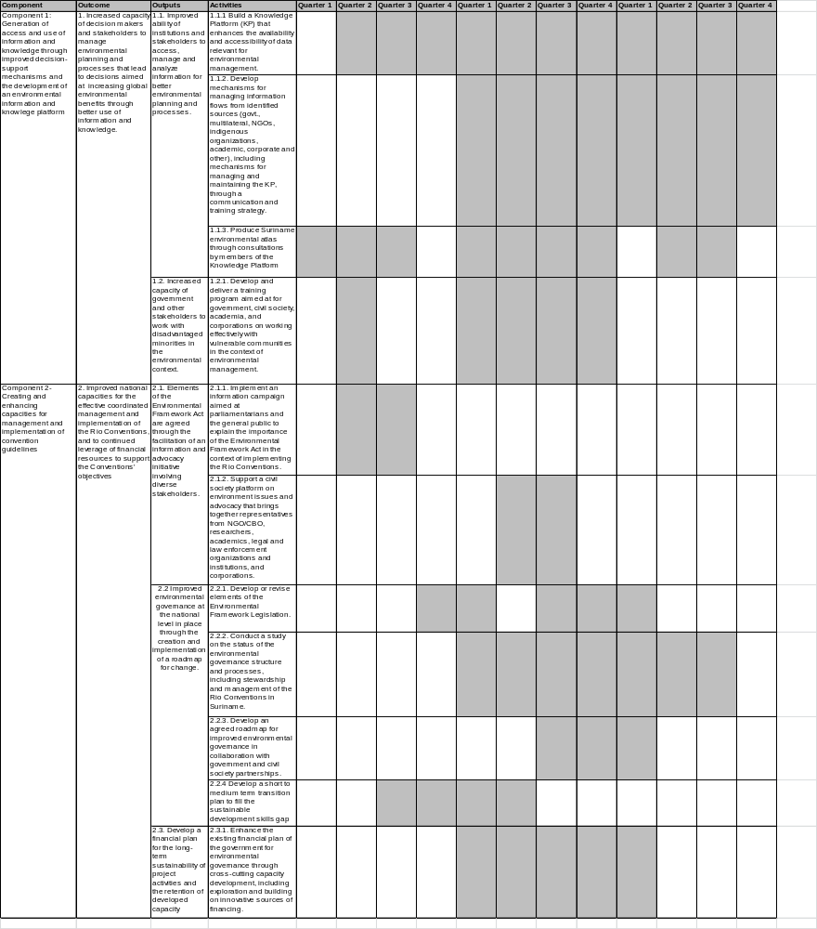

Annex 4. Terms of References

4. a Terms of Reference- Project Board

Project Description
The project is consistent with Suriname commitments on management of global environment and action plans on responding to multilateral agreements, in particular the Rio Conventions to which Suriname is a party. While Suriname has made some progress in implementing the Conventions, there is no integrated approach for sustainable planning and development as required by the Rio conventions.

Suriname completed its National Capacity Self-Assessment (NCSA) in 2009. This proposed project specifically reponds to the following findings/recommendations from the NCSA process:

- Establishing and strengthening of the institutional framework;
- Entering into and strengthening cooperation mechanisms;
- Increasing environmental awareness and community participation;
- Using a multi-dimension approach to the formulation of the national environmental
Policy
In order to respond to the priority capacity constraints for national and global environmental management, this project will strengthen Suriname capacities to integrate Rio Conventions issues into national and local decision-making.

The project strategy is therefore threefold:
- Strengthening the policy/institutional framework for implementing the Rio Conventions;
- Building capacity in government agencies and academia to implement the Rio Conventions through their work programmes;
- Initiating the process to develop public awareness in support of implementing the Rio Conventions.

The project will be implemented in line with the established Government of Suriname and UNDP procedures in Suriname. The Ministry of Labour, Technological Development and Environment (ATM) will take overall responsibility for implementation of the project, and for the project success. It will establish the necessary planning and management mechanisms to oversee project inputs, activities and outputs. The UNDP CO will support the Ministry as necessary.
Project Board
The Project Board will provide management advice, administrative support and oversee the direction of the project. The Project Board will provide support and management, and may provide technical inputs and recommendations to the Project Manager. The Board will review progress and evaluation reports, and approve programmatic modifications to project execution, as appropriate and in accordance to UNDP procedures. The Project Board will also review project achievements and ensure the quality assurance of the project outcomes.

The Project Board will also:
- Provide technical oversight to the project;
- Review project objectives and technical outputs;
- Support collaborative efforts among relevant partners and make recommendations for improvements;
- Provide guidance to the Project Manager on partnerships and co-funding opportunities for consideration;
- Review progress and provide guidance on long term sustainability of the project’s achievements.

The Project Board shall meet at least twice a year and may meet more often as required at UNDP headquarters. The Project Board will be chaired by ATM who will also provide secretariat services by coordinating meetings, producing documentation and minutes, managing correspondence, information management/ dissemination and related tasks. Documents will be made available to the Project Board at least one week (five working days) before the meeting. Minutes of the meetings will be prepared by the Project Manager.

Membership of the Project Board will include:
- ATM (Chair)
- ABS
- NIMOS
- ROGB
- CELOS
- Finance
- SBB
- National Institute for Environment & Development.
- Representatives from the Maroon and Amerindian communities
- Suriname Conservation Fund
- UNDP

Decisions will be made by consensus.

4.b Terms of Reference- National Project Director

The Government of Suriname must appoint a national director for this UNDP-supported project. The National Project Director supports the project and acts as a focal point on the part of the Government. This responsibility normally entails ensuring effective communication between partners and monitoring of progress towards expected results.
The National Project Director is the party that represents the Government’s ownership and authority over the project, responsibility for achieving project objectives and the accountability to the Government and UNDP for the use of project resources.
In consultation with UNDP, the Ministry of Labor, Technological Development and Environment as the concerned ministry, will designate the National Project Director from among its staff at not lower than the Deputy Minister or Head of Department level. The National Project Director (NPD) will be supported by a full-time National Project Manager (NPM).
Duties and Responsibilities of the NPD
The NPD will have the following duties and responsibilities:
- Assume overall responsibility for the successful execution and implementation of the project, accountability to the Government and UNDP for the proper and effective use of project resources)
- Serve as a focal point for the coordination of projects with other Government agencies, UNDP and outside implementing agencies;
- Ensure that all Government inputs committed to the project are made available;
- Supervise the work of the National Project Manager and ensure that the National Project Manager is empowered to effectively manage the project and perform duties effectively;
- Select and arrange, in close collaboration with UNDP, the appointment of the National Project Manager (in cases where the NPM has not yet been appointed);
- Supervise the preparation of project workplans, updating, clearance and approval, in consultation with UNDP and other stakeholders and ensure the timely request of inputs according to the project work plans;
- Represent the Government institution (national counterpart) at the tripartite review project meetings, and other stakeholder meetings.

Remuneration and entitlements
The National Project Director may not receive monetary compensation from project funds for the discharge of his/her functions.

4.c Terms of Reference- National Project Manager

The Project Manager will be recruited for the duration of the project. The Project Manager will undertake responsibilities associated with the execution of the project activities, which include:
- Organizing project activities
- Managing the work of other consultants
- Monitoring and reporting of project performance and delivery to the Project Board, ATM and UNDP
- Facilitate collaborative and consultative processes to ensure participation by government stakeholders
- Facilitating public awareness activities
- Lead organizer of training workshops and meetings
- Drafting documents and reports for Project Board
- Organizational and logistical issues related to project execution per UNDP guidelines and procedures
- Record keeping of project documents, including financial in accordance with audit requirements
- Facilitate timely preparation and submission of financial reports and settlement of advances, including progress reports and other substantial reports
- Identification and resolution of logistical and organizational problems, under the guidance of the Project Board

The Project Manager will have a post-graduate degree in public administration, or natural resources management or related field, and have a minimum of seven (7) years’ experience in progressively responsible and substantive areas in environmental and natural resource governance programming and planning.

Annex 5. Environmental and Social Criteria
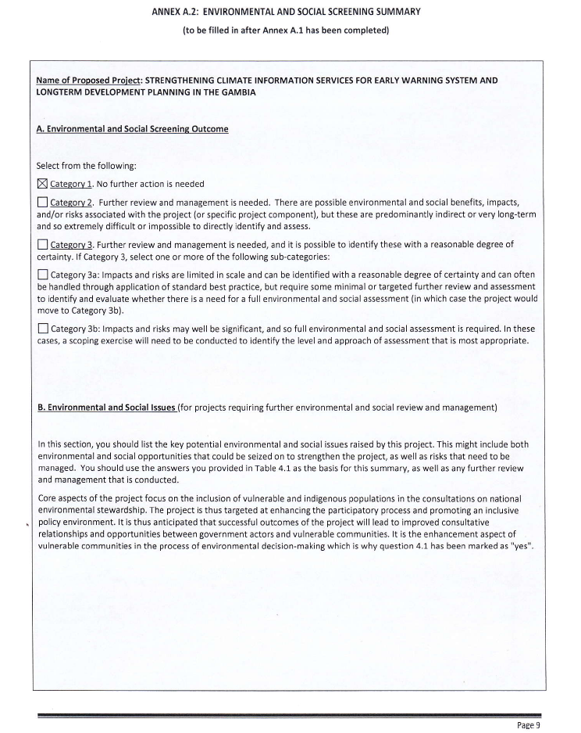
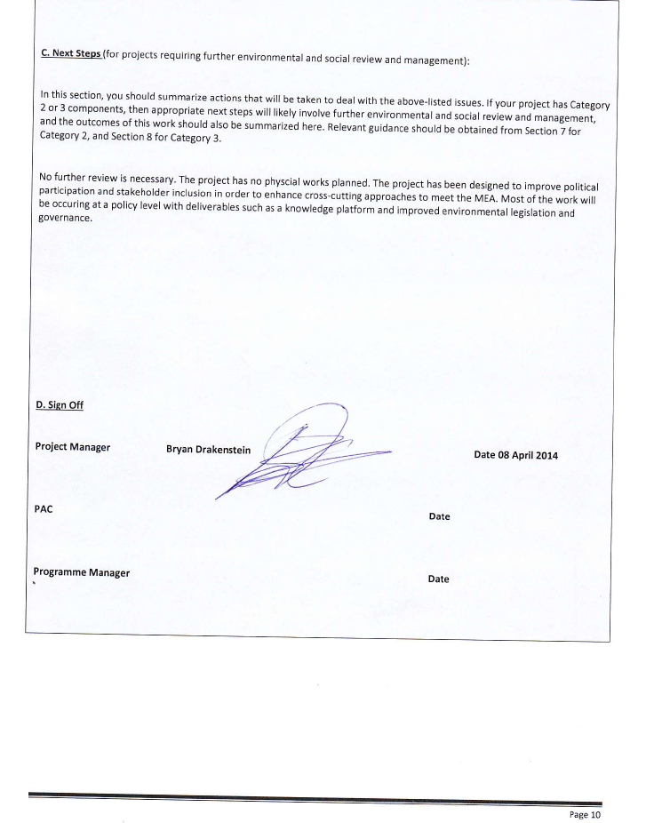

Annex 6. PPG Status Report

The activities undertaken within the framework of PPG were directed towards the design and development of the medium size project “Mainstreaming Global Environment Commitments for Effective National Environmental Management.”
The Project Preparation Stage involved a study of the gaps and weaknesses identified in the NCSA, followed by an analysis of baseline activities as a follow up to the NCSA Action Plan. It also involved consultations with multi-sectoral government and non-governmental stakeholders to foster an understanding of cross-cutting development needs and determine priority activities. Inception and validation missions were held and there was active participation in both inception and validation workshops. Activities and outputs were developed in collaboration with ATM and in consultation with UNDP partners. The validation workshop was organized to validate the preparatory findings, reaffirm the project approach, and obtain consensus on proposed activities. Government and university endorsement was also tested during the validation workshop and co-financing letters were sought.
These processes, consultations and findngs all feed in the draft project document and Request for CEO Endorsement, which came out as final products of the Project Prepation Stage. The finalized Project Document and GEF Request for CEO Endorsement are drafted and presented herewith.
The findings obtained during the preparatory phase confirmed that the approach identified during the PIF stage remains valid. Outputs and activities were readjusted however to address the identified barriers. In analysing the activities required to address these and achieve the outcomes identified in the PIF, the budget was re-adjusted among the two components. The changes from the PIF include:

PIF | Project Design | Rationale for Change
The outputs under Component 1 originally read:  1.1.1 Ability of institutions and stakeholders to use different new tools and methodologies available to manage information for better environmental planning and processes  1.1.2 Ability of stakeholders to diagnose, understand and transform information and knowledge into local actions increased and retained | 1.1.1 Improved ability of institutions and stakeholders to access, manage and analyze information for better environmental planning and processes.  1.1.2. Increased capacity of government and other stakeholders to work with disadvantaged minorities in the environmental context. | For Output 1.1.1, this is merely a rephrasing of the text, and to focus not just on management and new tools, but also on access to information, which was a gap identified during the PPG.  The Output 1.1.2 has been altered significantly to bear emphasis on the role of vulnerable communities. The lack of interaction with vulnerable communities was highlighted as a problem in the NCSA and requires continual work to enhance relationships particularly on environmental questions. Given that much of the vulnerable communities reside in the Interior, home to a variety of biological resources, and are custodians of environmental goods & services while also being engaged with mining activities which may have negative impacts on the environment, in order for successful environmental frameworks, it is necessary to include vulnerable populations. These populations are also home to indigenous knowledge and data that has not been captured. It is anticipated that the emphasis on effective consultation with vulnerable interventions will transform knowledge and information into local actions for sustainable development.
Under Component 2:  Output 2.1.1 Strengthening of the existing structures and coordination mechanisms to institutionalize and streamline collaboration and coordination across agencies and other relevant actors to ensure the continued legitimacy of programmes and plans to meet global environmental priorities.  Output 2.1.2 Negotiated financial commitments to finance the implementation of activities to deliver global environmental outcomes from within government budgetary allocations and other national sources  Output 2.1.3 Improved effectiveness of the institutions that work with the conventions and enhanced functioning of the political, economic and social system | Output 2.1.1 Implement an information campaign aimed at parliamentarians and the general public to explain the importance of the Environmental Framework Act in the context of implementing the Rio Conventions.  Output 2.1.2 Improved environmental governance at the national level in place through the creation and implementation of a roadmap for change.  Output 2.1.3. Develop a financial plan for the long-term sustainability of project activities and the retention of developed capacity | The wording of Output 2.1.1 was changed to specify what legislation the project will target, and how to achieve some momentum on it. The Environmental Framework Act, although in draft form, has yet to come to fruition and there have been concerns that the parliamentarians who will put it into effect, may not have enough awareness on all its implications. This output also targets the lack of awareness at the general public level on the laws that exist on environmental issues and how they govern people’s day to day activities. Thus the new output 2.1.1. is far more concretized.  The new output 2.1.2 is also a variation on the PIF’s output 2.1.3. The new wording has emphasis on establishing environmental governance at the national level, and in order to achieve this there will be the development and implementation of a roadmap for change. This roadmap with be created in collaboration with non-governmental stakeholders so that there can be country-wide ownership and adherence to it. Thus this new text points to a more concrete output of what this project is to deliver.  The new output 2.1.3 is a variation of the PIF’s output 2.1.2. It also focuses on securing a financial stream for sustainable development activities, but this output widens the scope of where this funding can come from. Whereas the original output in the PIF focused on national budget allocations, this output allows the exploration from other sources (e.g. public private partnership etc), but focuses both on the idea of sustainability and on establishing a financial plan to establish that sustainability. At the heart of this change is the idea that the project should have an output that maintains sustainability long after the duration of the project. The establishment of a financial plan will serve to develop a planning tool for the future.
Co-financing: The PIF identified co-financiers as ATM, Finance, Climate Compatible Development Agency (CCDA), ROGB, ADEK University, & CELOS | The project design no longer has CCDA as a co-financier. It has also added ABS as a co-financing partner. | CCDA has been removed as a co-financier as it has been discontinued. ABS has been added on as a co-financing partner as several linkages were sought and made with ABS during the PPG. As, the host of DEVINFO and the Statistics Bureau which publishes annual information on national environmental indicators, ABS has experience in data management and collection. Since it collects information on all sectors it can also act as point of integration for cross-cutting information.
Financing allocation between components: the initial PIF anticipated the indicative grant amount of 450,000 for Component 1 and 450,000 for Component 2 | Project design: indicative grant amount of $601,000 for Component 1 and $295,000 for Component 2 | Once the activities were refined during the PPG, the amount being requested for Component 1 & 2 had to change. Although the overall budget is the same, it became clear that the technical and research elements of the knowledge platform, and the monitoring activities for the environmental atlas would require more costly inputs to be effective. Component 2 however, which is more policy-oriented and based more upon cross-sectoral dialogue and collaboration would require less costly inputs such as meetings and workshops.
Project Management costs 80,000 USD | Project Management costs 84,000 USD | The salary of the project manager has been increased by four thousand dollars to attract qualified staff and remain competitive with other projects.

PPG Grant approved at PIF: US$ 20,000
Project Preparation Activities Implemented | GEF Amount ($)
Project Preparation Activities Implemented | Budgeted Amount ($) | Amount Spent to date($) | Amount Committed ($)
Background analysis of existent environmental databases, tools and methods, and their management systems to consider all data categories for global environmental management of the new platform to be created. | 3,000 | 3000
a) Background analysis of existent Government structures and coordination mechanisms for decision making (strengths and weaknesses of the current national institutions responsible for environmental issues).  b) Preliminary analysis of Funding scenarios to be developed. | 3,000 | 3000
Draft MSP strategy; Preparation of MSP document per UNDP/GEF guidelines: detailed budget, work plan, and logical framework.  Facilitate a stakeholder workshop to validate project strategy and obtain feedback on the basic elements of the MSP proposal; On-going consultations with donors and final donors’ roundtable to present final MSP and secure donor co-financing). | 13,000 |  | 13000
PG Management: one national expert, plus one validation workshop, plus communications, printing (all activities). | 1,000 | 796 | 204
Total | 20,000 | 6,796 | 13,204

Annex 7. Standard letter of agreement between UNDP & Government of Suriname

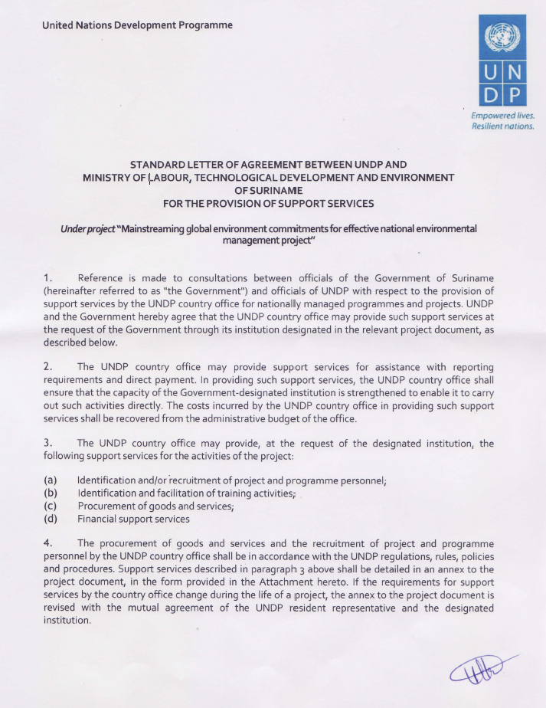
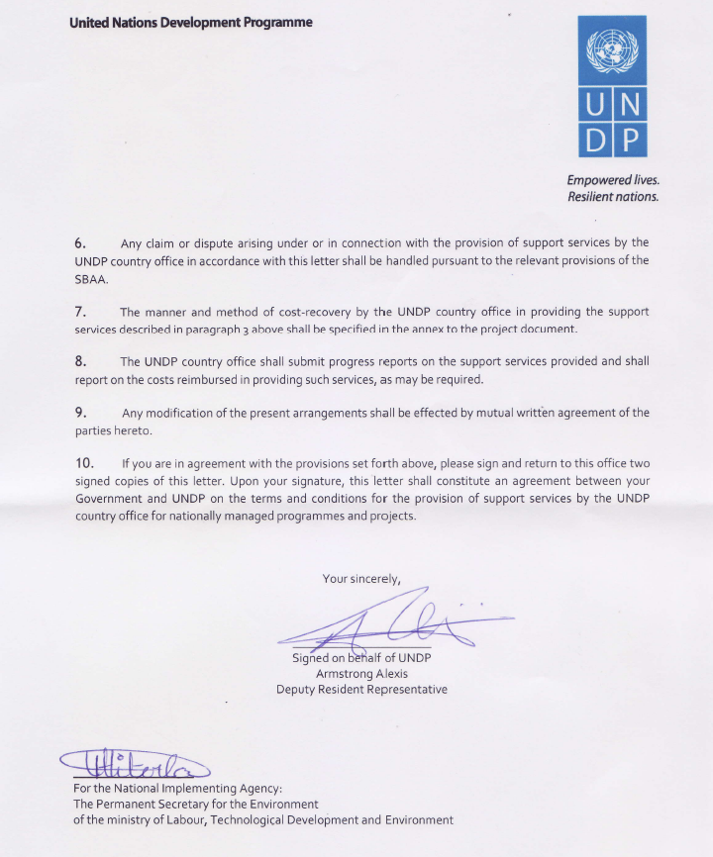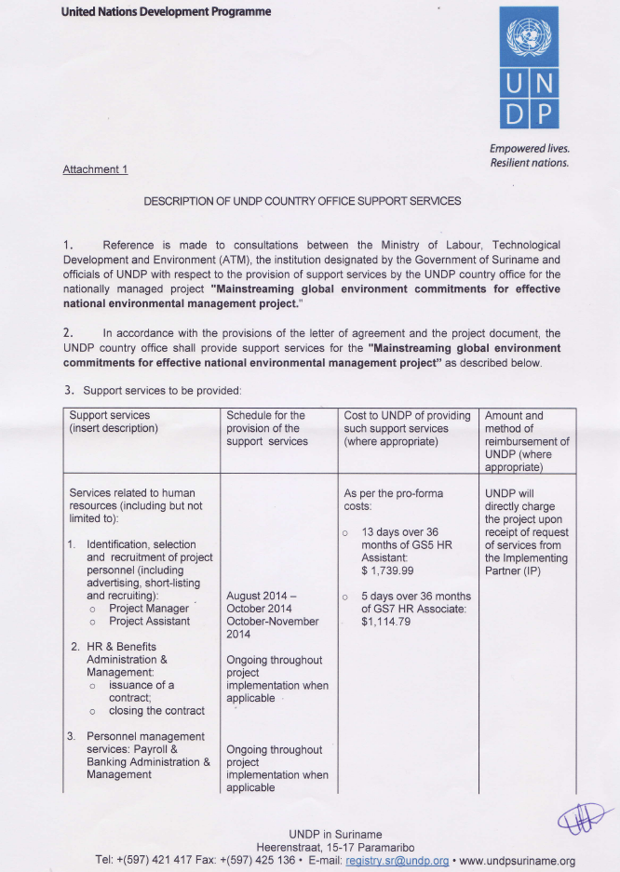
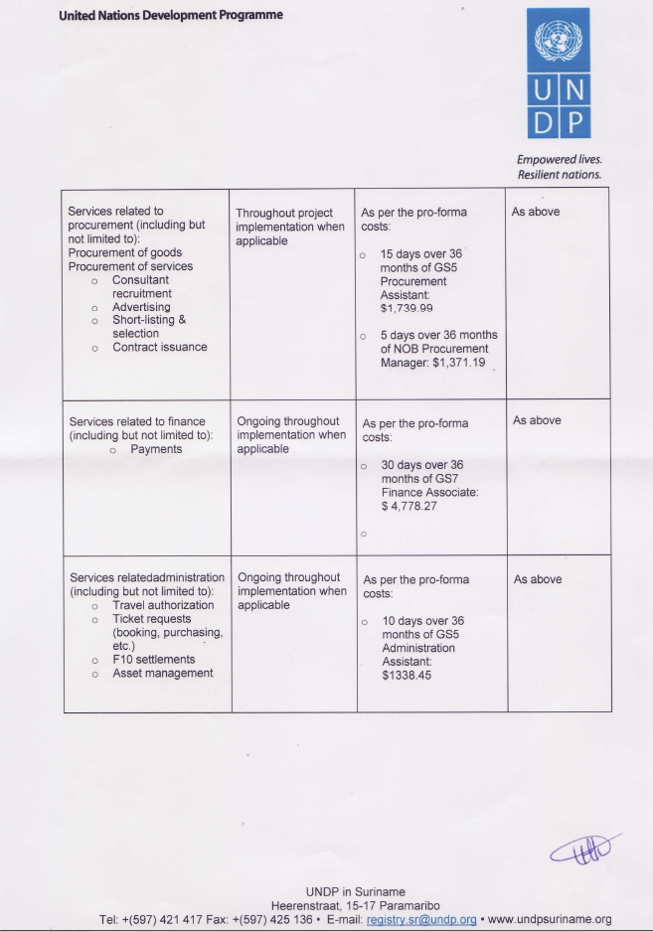
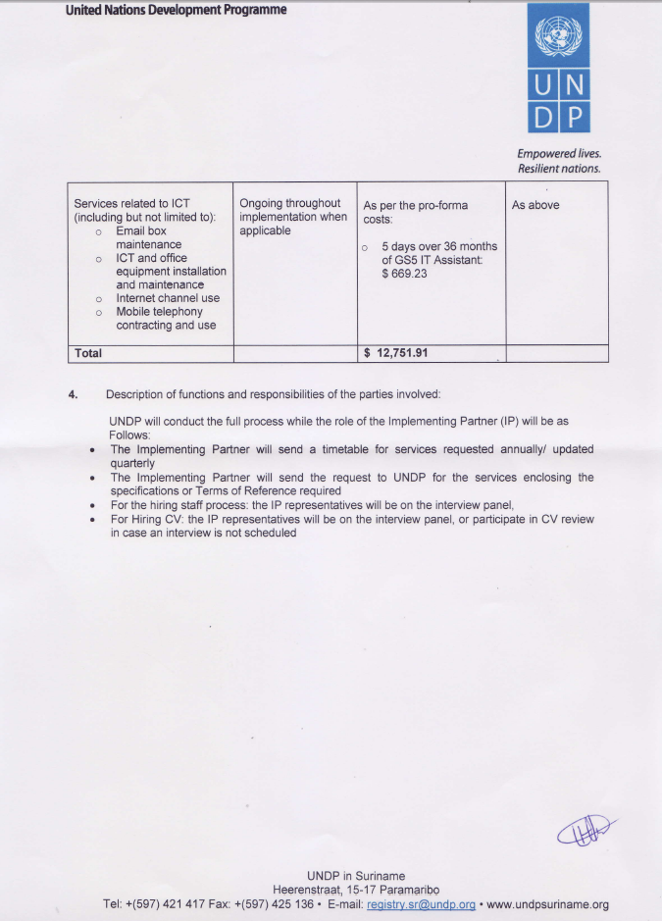

Annex 8. GEF endorsement letter

Annex 9. Letters of co-financing (attached separately)

Surinfo, online at: http://www.surinfo.org/. Accessed on March 2, 2014
Preliminary results of the 8th Census, (Free Website copy). The difference is made in this publication between ‘de jure’ (534,189) and ‘de facto’ (549,657) inhabitants. The number quoted is ‘de jure’, since all available tables in this document referred to these numbers.
Research Update: Republic of Suriname Outlook Revised to Positive; 'BB-/B' Ratings Affirmed, Standard and Poor’s Ratings Service, April 25, 2013. See: http://www.cbvs.sr/images/content/international-reports/suriname4.25.2013.pdf
Ibid.
The United Nations Collaborative Programme on Reducing Emissions from Deforestation and Forest Degradation in Developing Countries (UN-REDD): Readiness Preparation Proposal (R-PP) for Suriname. 23 February 2013
Suriname National Capacity Self-Assessment-Thematic Assessment UNFCCC, August 22, 2008
Suriname National Biodiversity Action Plan 2012-2016
The United Nations Collaborative Programme on Reducing Emissions from Deforestation and Forest Degradation in Developing Countries (UN-REDD): Readiness Preparation Proposal (R-PP) for Suriname. June 2013
Government of Suriname: National Capacity Self-Assessment, Capacity Development Action Plan, Final Version April 2009
Deltares: Integrated Coastal Zone Management Suriname.
Inception Report, 2013
Third International Conference on Small Island Developing States: Caribbean Regional Synthesis Report.
Ibid.
Suriname has recently completed the formulation of the Second National Communication to UNFCCC, which is to be submitted yet. The country has also prepared four National Reports to the UN Convention on Biological Diversity since it signed the Convention in 1992 and ratified it in 1996. The last of these progress reports dates from October 2012.
Third International Conference on Small Island Developing States: Caribbean Regional Synthesis Report. 2013 .
Heemskerk, M & Apapoe, I. Gender Equality, Gender Relations and the Position of Women in Suriname: A Situation Analysis. 201
Ibid.
Ibid.
Suriname Economy Profile 2013, online at: http://www.indexmundi.com/suriname/economy_profile.html, accessed January 2014.
Noted by WWF during inception mission; see inception report
Sara O.I. Ramirez-Gomez, Gregory G Brown, Annette Tjon Sie Fat. Participatory Mapping with Indigenous Communities for Conservation: Challenges and Lessons from Suriname in The Electronic Journal of Information Systems in Developing Countries.online at: ejisdc.org
Summary table should include all financing of all kinds: GEF financing, cofinancing, cash, in-kind, etc...
Suriname and the GEF. Available online at: http://www.thegef.org/gef/sites/thegef.org/files/publication/Suriname%20Country%20Fact%20Sheet_English.pdf

